 | Issue - 24 -  Epsom & Ewell F.C.  v  Camberley Town  Saturday, 21st April 2012
For today’s final League match at the Moatside, we welcome the players, officials and supporters of Camberley Town, today's officials, and of course our own regular supporters.

It is an unusual co-incidence that the Krooners are our visitors today as this was the case when we played our final game at Merland Rise two years ago. That match was also the last time that we defeated them, as we lost three times last season and also 4-0 at Krooner Park last November. Could history repeat itself today as we aim to close our tenure here with a win?

I’d like to say that we have had two wonderful years at the Moatside, but it hasn’t been the case. Although Merstham F.C. themselves have been very helpful and friendly to us, on the pitch it hasn’t worked out, while the journey from our home Borough has been a bit too far for many people to travel. Our next “home” will be nearer to Epsom and will hopefully result in more success too.

Recent results have removed the spectre of relegation from our shoulders. We secured a useful point in a 1-1 draw at Champions Guildford City and followed this up with a 2-0 home win over Banstead Athletic, Then last Saturday we upset the form book with a 2-0 win at Egham Town which, coupled with other results was enough to secure our safety for next season.

So what lies ahead in the Summer? We face another football tournament with limited aspirations for a change, so maybe England will go further this time, you never know! We have Wimbledon to look forward to, and visits from the West Indies and South Africa in the cricketing arena. Then as the football season kicks in again we have the Olympics. A once in a lifetime experience that I for one am really looking forward to, but maybe that’s because I have tickets to the 200 metres final!

Of course, by then we will be well into our pre-season friendlies. I had hoped to be in a position to announce the venue and opponents for the sixth Dave Wilson Trophy by now, but this is something that you will now have to check the website for during the summer. The new season kicks off on 4th August and the fixtures for our new term at Chipstead will of course be announced as soon as we know them.

In the meantime, thank you for your support and we hope to see you next season with plenty of your friends and colleagues in tow!

Enjoy the game and the Summer break!

Richard

Cover photo this week by Gemma Jarman

Ben Hayward taps in the second goal against Banstead
in front of our jubilant supporters on Easter Monday

Cherry Red Records Combined Counties League
Premier Division Table
inc Tuesday 17th April | P | W | D | L | F | A | Pts | GD
Guildford City | 40 | 30 | 7 | 3 | 122 | 44 | 97 | +78
Windsor | 40 | 27 | 9 | 4 | 119 | 42 | 90 | +77
Egham Town | 40 | 24 | 4 | 12 | 99 | 63 | 76 | +36
Hanworth Villa | 40 | 24 | 6 | 10 | 110 | 53 | 75** | +57
Molesey | 40 | 22 | 4 | 14 | 93 | 59 | 70 | +34
Camberley Town | 40 | 21 | 4 | 15 | 105 | 65 | 67 | +40
Horley Town | 40 | 20 | 5 | 15 | 75 | 57 | 65 | +18
South Park | 41 | 19 | 7 | 15 | 83 | 56 | 64 | +27
Wembley | 40 | 16 | 11 | 13 | 64 | 60 | 59 | +4
Raynes Park Vale | 40 | 17 | 7 | 16 | 68 | 90 | 58 | -22
Cove | 41 | 15 | 7 | 19 | 73 | 107 | 52 | -34
Epsom & Ewell | 40 | 15 | 8 | 17 | 69 | 74 | 47* | -5
Croydon | 41 | 13 | 8 | 20 | 62 | 74 | 47 | -12
Sandhurst Town | 40 | 15 | 2 | 23 | 62 | 102 | 47 | -40
Ash United | 40 | 13 | 7 | 20 | 69 | 80 | 46 | -11
Farnham Town | 40 | 12 | 10 | 18 | 59 | 76 | 46 | -17
Badshot Lea | 40 | 13 | 7 | 20 | 62 | 85 | 46 | -23
Dorking | 40 | 12 | 8 | 20 | 49 | 94 | 44 | -45
Chessington & Hook | 40 | 12 | 4 | 24 | 56 | 97 | 40 | -41
Colliers Wood United | 39 | 10 | 8 | 21 | 59 | 87 | 38 | -28
Mole Valley SCR | 41 | 11 | 4 | 26 | 57 | 98 | 37 | -41
Banstead Athletic | 41 | 9 | 7 | 25 | 52 | 104 | 34 | -52

- ** Hanworth Villa - ineligible player v Croydon: - 3 points deducted
- * Epsom & Ewell - ineligible players v Croydon & Banstead: - 6 points deducted

Lucky Day? – 21st April
Played 19 - Won 7 Drawn 3 Lost 9 - F 33 A 29 - PPG 1.26 - Below Average
Club record against today’s opponents
Played 77 - Won 34 Drawn 20 Lost 22 Abandoned 1
F 144 A 105 - PPG 1.58 - Above Average
Last visit
5th March 2011 - Lost 1-2 - Combined Counties League

Lyndon Buckwell

Hello everyone and welcome to Camberley Town, who always provide difficult opposition.

It’s been a difficult few weeks that has seen us drop alarmingly down the league table and into the Relegation zone.

We could use the excuse that we were docked six points earlier in the year, which wasn't the fault of the players and management, but to be honest with the players we've got, we should have had more points on the board anyway.

Never the less, the lads do deserve some credit for working hard and turning things around with two wins and two draws from our last four games which means we are now safe from the drop,

We always knew we had good players at the club, but we were making silly mistakes every game and it was costing us points. I said in previous match notes that if we worked a bit harder as a team and stopped giving away sloppy goals then we would start picking up points and that's basically what's happened.

We've now taken points off from all the top six sides this season apart from Camberley but hopefully we can put that right this afternoon.

Thanks for your support over the season and I hope to see you all at Chipstead for 2012/13.

Enjoy the game

Lyndon

All Remaining Results and Fixtures
Combined Counties League – Saturday 7th April
Banstead Athletic | 0-1 | Horley Town
Croydon | 1-3 | Chessington & Hook United
Farnham Town | 0-1 | Dorking
Guildford City | 1-1 | Epsom & Ewell
Hanworth Villa | 3-0 | Camberley Town
Molesey | 3-1 | Egham Town
Raynes Park Vale | 3-2 | Badshot Lea
Sandhurst Town | 1-3 | Wembley
South Park | 1-2 | Colliers Wood United
Windsor | 4-2 | Ash United
Combined Counties League – Monday 9th April
Ash United | 2-2 | Farnham Town
Badshot Lea | 3-2 | Sandhurst Town
Camberley Town | 0-4 | Cove
Chessington & Hook United | 0-2 | Molesey
Dorking | 0-5 | Guildford City
Egham Town | 1-3 | Windsor
Epsom & Ewell | 2-0 | Banstead Athletic
Horley Town | 1-3 | South Park
Raynes Park Vale | 2-2 | Colliers Wood United
Wembley | 1-5 | Hanworth Villa
Combined Counties League – Saturday 14th April
Banstead Athletic | 3-4 | Farnham Town
Camberley Town | 1-2 | Molesey
Chessington & Hook United | 1-3 | Sandhurst Town
Colliers Wood United | 0-2 | Windsor
Game played at Molesey F.C.
Croydon | 1-5 | Wembley
Dorking | 1-1 | Hanworth Villa
Egham Town | 0-2 | Epsom & Ewell
Guildford City | 4-2 | Raynes Park Vale
Horley Town | 1-1 | Cove
Mole Valley SCR | 2-1 | Ash United
Combined Counties League – Tuesday 17th April
Egham Town | 3-0 | Molesey
Hanworth Villa | 4-1 | Farnham Town
Combined Counties League – Saturday 21st April
Ash United | V | South Park
Badshot Lea | V | Wembley
Cove | V | Banstead Athletic
Epsom & Ewell | V | Camberley Town
Farnham Town | V | Croydon
Hanworth Villa | V | Horley Town
Mole Valley SCR | V | Colliers Wood United
Molesey | V | Dorking
Raynes Park Vale | V | Chessington & Hook United
Sandhurst Town | V | Egham Town
Windsor | V | Guildford City
Combined Counties League – Tuesday 24th April
Colliers Wood United | V | Ash United
Game to be played at Cobham F.C.
Combined Counties League – Friday 27th April
Colliers Wood United | V | Epsom & Ewell
Game to be played at Cobham F.C.
Combined Counties League – Saturday 28th April
Camberley Town | V | Windsor
Chessington & Hook United | V | Hanworth Villa
Dorking | V | Badshot Lea
Egham Town | V | Farnham Town
Guildford City | V | Molesey
Horley Town | V | Sandhurst Town
Wembley | V | Raynes Park Vale

EL Records League Cup Final
@ Cherrywood Road, Farnborough F.C. - Friday, 4th May
Guernsey F.C. | V | Colliers Wood United

Surrey Senior Cup Final
Final @ Kingsmeadow - Tuesday, 8th May
Woking | V | Corinthian Casuals /  Sutton United

From behind the goal
Guildford City 1-1 Epsom & Ewell - Combined Counties League
Saturday 7th April 2012

The Spectrum. Never a particularly inspiring venue, and one that we may not be visiting for a while as Guildford City look like they will be going up to Step Four as Champions this season, repeating their achievements of last year. However, on the occasion of our final visit there our players had a really good go at their hosts, and although we rode our luck at times, we hung in and took a point with a late equaliser that was deserved as much for the quality of our defensive work as for the excellent finish from Martin Grant.

And I must start with our defence that has been much-maligned in recent weeks, but in place of the working Alex McKay we recalled former player Charlie West to go alongside Anthony Panayi, and after an initial wobbly five minutes we looked quite solid there for much of the match, repelling the incisive Guildford moves. The two Jamie's, Summers and Hatfield also played well and as they looked more solid our midfield grew in confidence.

I referred to a wobbly opening five minutes and we trailed just three and a half minutes into the game. Cutting straight through the middle a low shot was well saved by Nick Taylor-Greaves who stuck out a leg, but the loose ball went straight to Austin Gacheru who calmly struck it into the roof of the net from eight yards.

There were other dangerous moments. In the 14th minute a dangerous ball whizzed across the face of our goal while Taylor-Greaves also had to be alert to save a sliced cross that went straight at him. However, we also had chances of our own. Anthony Panayi will be too young to remember Franz Beckenbauer, but the German would have been proud of our youngster's defence splitting through ball and Grant was on to it in a flash. He had time, but chose to try and lift it over the exposed keeper early and it just cleared the bar from distance.

Five minutes later he had another shot and again it was reminiscent of another match against the old enemy as it took a wicked deflection and looped over everyone. However, whilst Peter Shilton was unable to reach that particular deflection in Italia 90, the home keeper was made of sterner stuff and just tipped the ball over the bar.

Our keeper was forced into a fantastic save ten minutes from half time when he got down and saved with his left hand, as the ball came through a wall of players following a block of the original free kick, and a couple of minutes later we were fortunate to see a long shot just graze our far post. They also nearly scored in the opening minute of the second half when their player cut in from the left but no one was there to finish the job. On the hour Taylor-Greaves made another great save and he was in action again to tip the ball around a post with a shot that he clearly didn't see until late. All of his work was looking like it would be for nothing though, until Grant collected the ball in the right channel and after holding off a defender he curled his shot left-footed into the far corner of the net from just outside the box. It was a wonderful finish and worth the admission money itself.

So could we last for twelve minutes plus injury time? Well in all honesty, Guildford should have gone ahead almost immediately from the restart when the ball came over from the left wing but somehow the oncoming player was wide with his close range shot. Things got more concerning when we were forced into a reshuffle at the back when West had to be replaced after 80 minutes, but Summers moved inside with youngster Danny Amos coming on at right back, and with exception of a great last ditch Summers clearance we saw the time out with few alarms.

In fact we had the best chance to win it after 87 minutes when a defensive error at the other end left Paul Gough in a bit of space and he cracked a stunning volley towards goal. A yard either side of the keeper and he wouldn't have had a sniff, but luckily for him he could reach it and the ball was cleared.

And it must be said that this was probably about right. Guildford are a very good side and an Epsom win wouldn't have been fair on them. However, we were well worth a point and we showed that when we get after the other teams in this division we can have success.

From behind the goal
Epsom & Ewell 2-0 Banstead Athletic - Combined Counties League
Monday 9th April 2012

A match that has been often quoted as the most passionless local derby in football took on added importance for a change on Monday morning. We needed the points to avoid the drop to the lower division of the Combined Counties League and were also keen to end a run of five straight home defeats at the Moatside. For the visitors it was an even bigger game as they were rooted to the bottom of the table and anything less than a win would leave them with a mountain to climb.

In terms of personnel, Charlie West kept his place at the expense of the returning Alex McKay, while Ben Hayward came in for Paul Gough. Mark Jarman came in up front originally ahead of James Cottee, but Martin Grant's non-arrival proved to be the key moment of the match as Cottee had a fantastic game, scoring one and making the other of our two goals amongst many other things.

Faced with three former Epsom players in Robbie Burns, Tony Cuff and Dave Tidy the game was fairly even to start with. Banstead got a shot on target in the eleventh minute but it was deflected away by West for a corner. Burns had a half chance ten minutes later but his run and flick from distance was tipped over the bar by our star performer from the Guildford game Nick Taylor-Greaves, who had a much quieter day today.

As the game went on we began to get stronger. On the half hour, a half clearance under pressure from Tidy went straight to the feet of Cottee, but his side-footed volley from thirty yards went just wide of the goal as the keeper scrambled to make his ground. Minutes later Hayward glanced a header wide from a Jarman cross, and another good cross then came in from Jamie Summers but with Nathan Ayling stretching for the tap in, the ball was somehow knocked away by the heel of the defender for an incredible clearance.

However, our group behind the goal couldn't help noticing that Jarman was playing out on the right wing, while one of the best wingers we have had at the club in recent years, Ramzi Bedj Bedj was playing alongside Cottee. Fortunately, Jarman moved more centrally just before half time and his excellent pass from that position put Cottee through wide of goal. He sidestepped a challenge and clipped the ball over the keeper for an expert finish in the 44th minute.

The Jarman - Bedj Bedj anomaly was corrected at half time and we came out for the second half in a very confident manner. Hayward had a shot blocked after Cottee had held the ball up well, while in the 50th minute Bedj Bedj sliced through two men on the left wing and from the bye line crossed just too strongly for the incoming Cottee who would have had a tap in otherwise. Cottee was starting to run the show now, and he had a shot deflected into the air which Tidy was just able to reach, and moments later the busy Banstead keeper made a really good save at his near post to deny our flying striker again. Then Jarman got on the end of a great Summers cross but was a foot over the bar with his header. All of this, and the half was not yet ten minutes old.

This was a period of great dominance but as Guildford learned on Saturday, one-nil is a precarious lead. We needed a second and it came in the 57th minute, courtesy of a fantastic run by Cottee, who cut in from the right wing and beat two men before sliding the ball across goal for Hayward to tap in.

Cottee was in action once more with a flying header after 63 minutes but he was unable to direct it either side of the keeper who made a comfortable save, but the damage was done. Dominant in most areas of the park by this point, the opposition looked less and less likely to score, while in the 79th minute Cottee again hit the target with a low drive from outside the box, but Tidy was down to tip the ball wide. Towards the end Antony Myers was unlucky with a shot that deflected just wide and by the end you could have argued that the 2-0 result should have been more.

I will finish by saying that we have three games left and it is worth getting along to watch James Cottee, as there is no way he can be playing football at this level for much longer. He was fantastic today and a great career beckons for this eighteen year old.

From behind the goal
Egham Town 0-2 Epsom & Ewell - Combined Counties League
Saturday 14th April 2012

You get some surprise results at the end of the season sometimes. Maybe a team has little to play for, while others, much lower down are fighting for their lives. What made Saturday’s result so good though, was that Egham were quite clearly looking for a third place finish and the F.A.Vase exemption that it would bring, so they did not take this game lightly, and facing a team that had three former players in it, we outplayed them, rendering them completely impotent at times.

The team was unchanged from the Easter Monday win over Banstead, apart from Paul Gough, who came in for the absent Ben Hayward, but the game started in the manner I thought it would, with Egham dictating the early play and looking quite lively in particular on the right wing, where their number 11 caused a bit of trouble with his tricky runs. I should point out that Ramzi Bedj Bedj nearly put us in front after just forty seconds, but the first twenty minutes were mainly ones of concern.

However, following an Egham shot from close range that actually went out for a throw in, we started to grow in confidence, and started to provide some threats of our own. Our front three of Mark Jarman, James Cottee and Bedj Bedj playing more centrally of the other two were causing a lot of trouble with their skills, work rate and their movement. One minute Jarman would be back on the right hand side of midfield, then the next he would be out on the left with Cottee switching, then they’d all be up front! Ably supported by Gough, Carl Downs and Nathan Ayling we looked quite compact, and the latter sent a long range warning sign just over our former keeper Paul Borg’s crossbar from fully thirty-five yards.

Ayling was also involved in a nice move in the 37th minute, when interplay between him and Bedj Bedj set up Cottee for a low shot that Borg parried out for a corner. Hatfield’s delivery was a disappointing one though, straight at their number 11, standing at the near post. He was unable to deal with it though, and shovelled the ball back out to our full back, who then avoided a despairing lunge from the 11, and curled in a really good cross with his supposed weaker right foot. It was right in the danger area and the Egham number seven met it first, his header giving his keeper no chance as it flew into the net.

We appeared to sit back towards half time. Jamie Summers made a good block, but I was concerned that we might be asking for trouble. To their credit, our Management ensured that we came back out in a positive frame of mind and really took the game to our hosts in the early period of the second period. Jarman had a curling effort that didn’t quite have the legs to beat Borg, while Ayling got down the left and cutting in, went for goal instead of squaring the ball. Cottee had a couple of dangerous runs and shots but we were getting a lot more space and Bedj Bedj made a similar run to Ayling’s in the 56th minute, but his pull back was handled and Bedj Bedj slotted the penalty in for the second goal.

From that point the game was over. Egham had a couple of half-chances but Nick Taylor-Greaves was alert to these and Anthony Panayi and Charlie West are looking quite a solid partnership right now. Hopefully they will be around to build on that next season. As for Egham, having picked up some good players recently, not just from Epsom, I thought that they were disappointing, particularly in the second half. Or maybe, we just made them look that way!

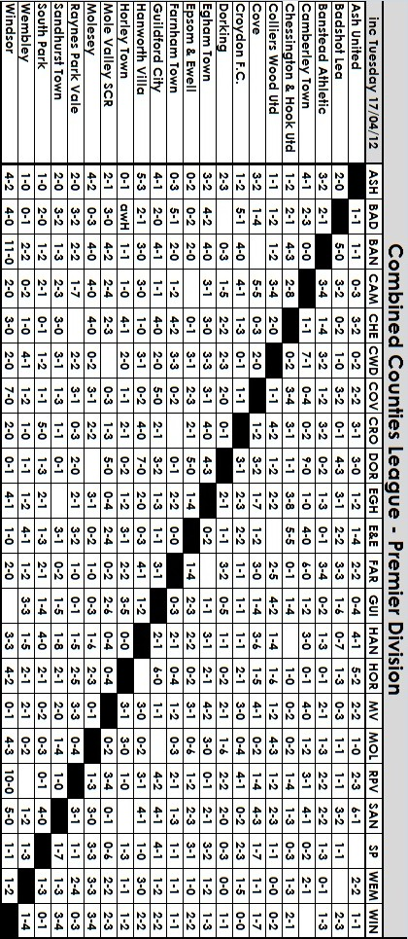
Club History - 21st April
Date | Day | Competition |  | Opponents |  | Scorers
21/04/28 | Sat | London League | A | Carshalton Athletic | 1-2 | Marlow
21/04/30 | Mon | London League | H | Beckenham | 4-2 | Carmichael,  Mackesy (2), Parker
21/04/34 | Sat | London League | A | Leavesden | 1-3 | M.Wiggins
21/04/37 | Wed | Friendly | H | Combined L.C.C.Hospitals | 4-1 | Rochester (3), Beglan
21/04/48 | Wed | Friendly | H | Guildford City Res | 4-0 | Gilbert (2), Young (2)
21/04/51 | Sat | Corinthian League | H | Eastbourne | 4-2 | Faggetter (2), Wright, Musto
21/04/54 | Wed | Corinthian League | H | Hounslow | 1-0 | Wiles
21/04/56 | Sat | Corinthian League | A | Chesham United | 0-1
21/04/73 | Sat | Athenian League Cup 2 | A | Ware | 0-2
21/04/75 | Mon | Surrey Senior League | A | Whyteleafe | 9-0 | Tuite (4), Bennett (pen), Lee (2), Webb, Wales
21/04/77 | Thur | Athenian League 1 | H | Worthing | 1-1 | Wales
21/04/79 | Sat | Isthmian League 1 | H | Wokingham Town | 1-0 | Tuite
21/04/84 | Sat | Isthmian League 1 | A | Wembley | 1-1 | Miles (pen)
21/04/90 | Sat | Isthmian League 2s | H | Feltham | 0-2
21/04/98 | Tue | Associate Members Trophy Final | N | Bedford Town | 0-2
21/04/01 | Sat | Isthmian League 3 | A | Wingate & Finchley | 0-1
21/04/03 | Mon | Isthmian League 1s | A | Banstead Athletic | 0-4
21/04/07 | Sat | Combined Counties Prem Div | A | Cobham | 0-3
21/04/09 | Tue | Combined Counties Prem Div | A | Chessington & Hook United | 2-2 | Burns (2)
Seasons in the Past
90 years ago – Epsom Juniors
26/04/22 | Wed | Epsom Hospital Cup Semi-Final Replay | H | Banstead | 2-0 | Matthews, Holliday
80 years ago – Epsom Town
20/04/32 | Wed | London League | H | Park Royal | 1-2 | Dunne
70 years ago – Epsom Town (war time)
25/04/42 | Sat | South Eastern Combination | H | Sutton United | 7-2 | Brown (4), Judge, Pullen, Williams
60 years ago – Epsom F.C.
14/04/52 | Mon | Corinthian Memorial Shield Final | N | Hounslow | 1-2 | Ford
50 years ago – Epsom & Ewell F.C.
23/04/62 | Mon | Corinthian League | H | Worthing | 1-2 | Millard
30 years ago – Epsom & Ewell F.C.
20/04/82 | Tue | Isthmian League 1 | H | Wokingham Town | 1-3 | Hill
20 years ago – Epsom & Ewell F.C.
18/04/92 | Sat | Isthmian League 3 | A | Hampton | 0-3
10 years ago – Epsom & Ewell F.C.
20/04/02 | Sat | Isthmian League 3 | H | Wokingham Town | 5-1 | Webb (2), Huckle (2), Hatton

21st April - In Summary
90 years ago this week Banstead were the opponents in the replay of the Epsom Hospital Cup Semi-Final. Although my records are sketchy for this era still it is quite possible that this was the very first home game played on our new ground in the Horton Hospital Grounds. V.Matthews and Charlie Holliday were the scorers as we advanced to a Final against Epsom Brotherhood although we were defeated 2-1 in that match played ten days later to close the season.

80 years ago this week Park Royal were the team to beat in the London League. However, no one could! They remained unbeaten all season and edged us out 2-1 at West Street in a match watched by our President Samuel Hill-Wood, who was also Chairman of Arsenal at the time!

70 years ago this week Sutton United visited for the replay of a League match from earlier in the season. It had been declared void as both teams had played ineligible players! Despite being the home team, we were a player short, so Sutton kindly loaned us a player and promptly regretted it as we led 5-0 at half time with George Brown the pre-war Wimbledon striker getting four of them, and eventually ended up as 7-2 winners.

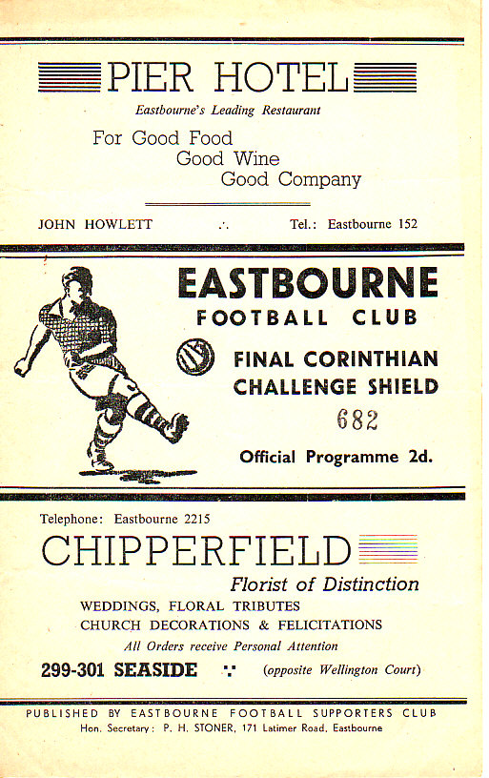
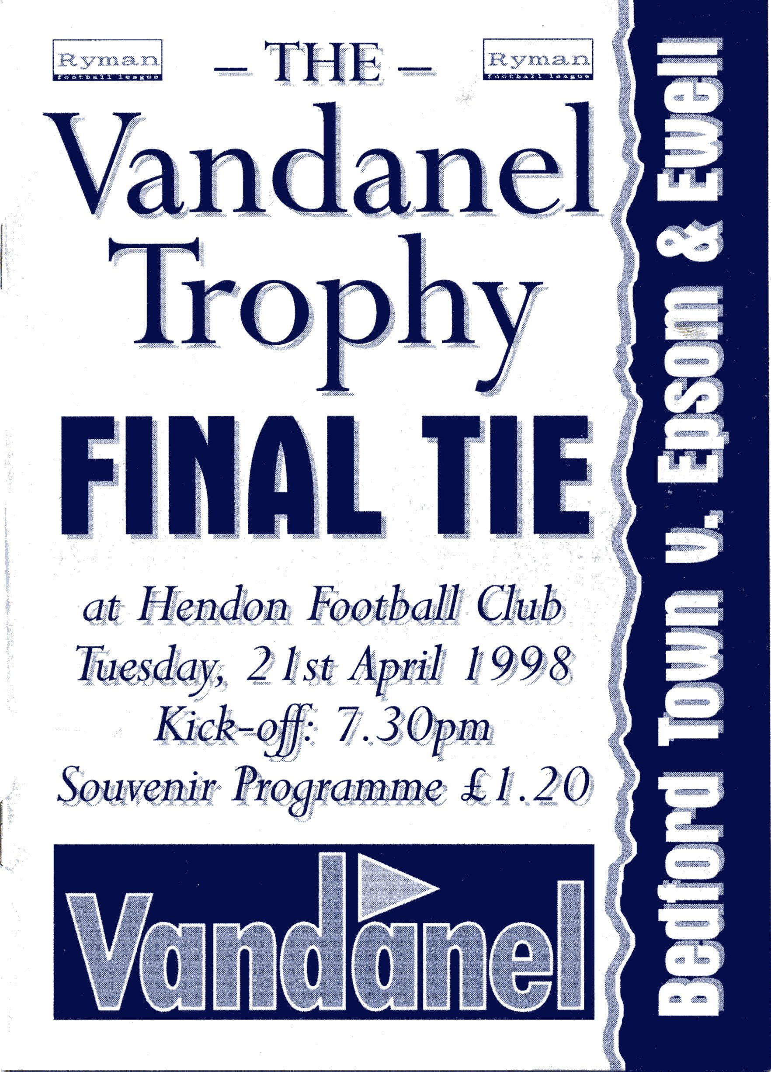
60 years ago this week 5,000 spectators from Hounslow and Epsom made the trek to Eastbourne’s Saffrons ground for the Memorial Shield Final. Hounslow were hot favourites and League Champions, but Denis Ford put us ahead in the 29th minute when he converted a Tommy Rochester cross. Unfortunately two goals in the 73rd and 74th minutes turned the game around and we were unable to equalise. (see programme above)

37 years ago today we recorded the biggest ever away win in our history as we crushed Whyteleafe 9-0 at Church Road just two days after our F.A.Vase disappointment. Tommy Tuite scored four of the goals.

14 years ago today we played our last competitive Cup Final when we met Bedford Town at Hendon F.C.’s much-missed Claremont Road ground in the Associate Members Trophy. We had beaten four clubs from a higher Division to get there, including a 1-0 win at Wealdstone in the Semi-Finals but it wasn’t our night as we hit the woodwork frequently, yet conceded one in each half to lose 2-0. (see programme left)

Above and Below
Ryman League Division One South Table
inc Saturday 14th April | P | W | D | L | F | A | Pts | GD
Bognor Regis Town | 38 | 25 | 9 | 4 | 100 | 35 | 84 | +65
Whitehawk | 38 | 27 | 6 | 5 | 75 | 26 | 84* | +49
Dulwich Hamlet | 38 | 25 | 8 | 5 | 70 | 24 | 83 | +46
Folkestone Invicta | 39 | 22 | 7 | 10 | 78 | 52 | 73 | +26
Maidstone United | 38 | 20 | 7 | 11 | 64 | 43 | 67 | +21
Godalming Town | 38 | 20 | 7 | 11 | 70 | 50 | 67 | +20
Worthing | 38 | 18 | 10 | 10 | 68 | 41 | 64 | +27
Merstham | 38 | 17 | 6 | 15 | 61 | 67 | 57 | -6
Chipstead | 38 | 16 | 8 | 14 | 58 | 49 | 56 | +9
Hythe Town | 38 | 16 | 7 | 15 | 58 | 60 | 55 | -2
Ramsgate | 39 | 16 | 7 | 16 | 60 | 70 | 55 | -10
Walton & Hersham | 38 | 13 | 7 | 18 | 49 | 51 | 46 | -2
Eastbourne Town | 38 | 11 | 12 | 15 | 46 | 58 | 45 | -12
Corinthian-Casuals | 38 | 11 | 12 | 15 | 46 | 59 | 45 | -13
Faversham Town | 38 | 10 | 10 | 18 | 41 | 61 | 40 | -20
Whitstable Town | 38 | 12 | 4 | 22 | 46 | 84 | 40 | -38
Crawley Down | 38 | 11 | 4 | 23 | 63 | 80 | 37 | -17
Walton Casuals | 38 | 10 | 6 | 22 | 45 | 71 | 36 | -26
Sittingbourne | 38 | 6 | 12 | 20 | 35 | 68 | 30 | -33
Whyteleafe | 38 | 5 | 9 | 24 | 35 | 66 | 24 | -31
Burgess Hill Town | 38 | 7 | 6 | 25 | 37 | 90 | 24* | -53
Croydon Athletic – Resigned – Record Removed

With just two matches remaining for most teams, a couple of three-point deductions could prove really costly here. Whitehawk pulled off a great 2-0 win at Dulwich Hamlet, but it may prove to be for nothing as both teams look likely to end up in the playoffs. Bognor Regis lead on goal difference from the Brighton side who will be rather upset if the deduction ultimately costs them promotion.

At the other end, Burgess Hill have also had three points removed, and with just one team going down, due to the imminent arrival in Step Six of AFC Croydon Athletic, it may be that Whyteleafe will just finish above the Sussex side as a result. The key team here are Whitstable Town who have to play both bottom sides in their remaining matches. They travel to Whyteleafe after hosting Burgess Hill, whose other match is against the high-flying Hamlet who are still desperate for the points.

Whyteleafe’s other match is at Crawley Down and right now I back the Surrey side to stay up. For the Hillians though, it could be the Sussex League and if they don’t bounce back, then following re-organisation they could be playing us in 2013/14.

Above and Below
Combined Counties League Division One Table
inc Tuesday 17th April | P | W | D | L | F | A | Pts | GD
Guernsey | 33 | 30 | 1 | 2 | 136 | 22 | 88* | 114
Bedfont Sports | 34 | 25 | 5 | 4 | 84 | 34 | 80 | 50
Hartley Wintney | 32 | 22 | 7 | 3 | 93 | 40 | 73 | 53
Warlingham | 33 | 18 | 7 | 8 | 70 | 48 | 61 | 22
Eversley | 33 | 18 | 5 | 10 | 80 | 53 | 59 | 27
Spelthorne Sports | 32 | 16 | 7 | 9 | 75 | 49 | 55 | 26
Staines Lammas | 32 | 17 | 3 | 12 | 67 | 51 | 54 | 16
Westfield | 34 | 16 | 4 | 14 | 64 | 65 | 52 | -1
Worcester Park | 33 | 14 | 6 | 13 | 81 | 73 | 48 | 8
Frimley Green | 34 | 11 | 7 | 16 | 55 | 82 | 40 | -27
Knaphill | 34 | 11 | 5 | 18 | 58 | 81 | 38 | -23
Cobham | 33 | 10 | 6 | 17 | 48 | 69 | 36 | -21
Feltham | 33 | 11 | 1 | 21 | 45 | 65 | 34 | -20
CB Hounslow United | 33 | 10 | 2 | 21 | 48 | 79 | 32 | -31
South Kilburn | 31 | 7 | 8 | 16 | 33 | 56 | 29 | -23
Farleigh Rovers | 32 | 7 | 6 | 19 | 43 | 78 | 27 | -35
Bookham | 33 | 4 | 6 | 23 | 32 | 94 | 18 | -62
Sheerwater | 33 | 3 | 6 | 24 | 48 | 121 | 15 | -73

It’s all sorted here!

For some time we have known that Guernsey were coming up, despite the three-point deduction, and they confirmed the title a few weeks back. Not far behind though were Bedfont Sports and they secured the runners-up spot soon after.

Now they have been joined by Hartley Wintney, who confirmed their place in the top three with two wins over the Easter period. There is a slight doubt over whether they could miss out on promotion, as the third placed team can sometimes miss out in the event that the division above is filled by clubs who transfer over from other Step Five Leagues, but with the impending F.A. re-organisation appearing very likely to take place at the end of next season, I would be surprised to see many teams moving this term.

So it seems very likely that we will be seeing all three of these clubs in League action at High Road next season. All will present difficult opposition for us, but then, this is becoming a very competitive league.

First Eleven Appearances - (max 47)
Name | Debut | 2011/12 |  |  |  | Career Totals
Name | Debut | App | Sub | Total | Goals | App | Sub | Total | Goals
AMOS Daniel | 03/03/12 | 0 | 7 | 7 | 0 | 0 | 7 | 7 | 0
AUGUSTINE Ryan | 10/03/12 | 0 | 4 | 4 | 0 | 0 | 4 | 4 | 0
AYLING Nathan | 15/11/08 | 26 | 7 | 33 | 3 | 26 | 14 | 40 | 3
BEDJ BEDJ Ramzi | 08/08/09 | 8 | 3 | 11 | 1 | 66 | 6 | 72 | 19
BURNS Robbie | 14/08/07 | 12 | 2 | 14 | 6 | 163 | 6 | 169 | 97
CHEADLE Adam | 31/03/12 | 0 | 1 | 1 | 0 | 0 | 1 | 1 | 0
COLES Dan | 06/08/11 | 19 | 2 | 21 | 0 | 19 | 2 | 21 | 0
COTTEE James | 26/11/11 | 20 | 4 | 24 | 13 | 20 | 4 | 24 | 13
DEWAR Ali | 29/10/11 | 13 | 3 | 16 | 1 | 13 | 3 | 16 | 1
DOWNS Carl | 17/09/11 | 26 | 3 | 29 | 2 | 26 | 3 | 29 | 2
FRANCIS Dave | 06/08/11 | 16 | 7 | 23 | 6 | 16 | 7 | 23 | 6
GOODWELL Adam | 14/01/12 | 3 | 1 | 4 | 0 | 3 | 1 | 4 | 0
GROBLER Dre | 21/08/11 | 9 | 3 | 12 | 0 | 9 | 3 | 12 | 0
GOUGH Paul | 28/02/12 | 5 | 5 | 10 | 1 | 5 | 5 | 10 | 1
GRANT Martin | 03/04/12 | 2 | 0 | 2 | 1 | 2 | 0 | 2 | 1
HARMSWORTH Matt | 10/09/11 | 0 | 3 | 3 | 1 | 0 | 3 | 3 | 1
HATFIELD Jamie | 11/11/06 | 27 | 3 | 30 | 0 | 159 | 10 | 169 | 5
HAYWARD Ben | 07/03/07 | 7 | 3 | 10 | 2 | 171 | 17 | 188 | 11
HOADLEY Harry | 27/08/11 | 1 | 0 | 1 | 0 | 1 | 0 | 1 | 0
JARMAN Mark | 08/08/09 | 36 | 6 | 42 | 17 | 68 | 23 | 91 | 34
JONES Adrian | 06/08/11 | 20 | 0 | 20 | 0 | 20 | 0 | 20 | 0
LUNN Kieran | 21/01/12 | 2 | 3 | 5 | 0 | 2 | 3 | 5 | 0
McGREGOR Alex | 08/08/09 | 24 | 9 | 33 | 2 | 86 | 35 | 121 | 9
McKAY Alex | 20/12/08 | 5 | 1 | 6 | 0 | 19 | 7 | 26 | 1
MOON James | 16/08/11 | 3 | 2 | 5 | 0 | 3 | 2 | 5 | 0
MYERS Antony | 23/12/06 | 21 | 7 | 28 | 3 | 44 | 8 | 52 | 6
ORDUNO Inaki | 06/08/11 | 4 | 1 | 5 | 1 | 4 | 1 | 5 | 1
PANAYI Anthony | 14/11/10 | 34 | 4 | 38 | 0 | 55 | 4 | 59 | 1
RICHARDS Ayden | 09/08/11 | 1 | 6 | 7 | 0 | 1 | 6 | 7 | 0
ROBINSON Sam | 22/10/11 | 14 | 1 | 15 | 3 | 14 | 1 | 15 | 3
RODRIGUES Alex | 05/04/07 | 26 | 3 | 29 | 0 | 238 | 3 | 241 | 2
ROWE Steve | 27/08/11 | 5 | 1 | 6 | 0 | 5 | 1 | 6 | 0
SIEFERS Tom | 29/08/11 | 9 | 7 | 16 | 0 | 9 | 7 | 16 | 0
SMITH Joshua | 07/04/12 | 0 | 2 | 2 | 0 | 0 | 2 | 2 | 0
SMITH Martin | 14/01/12 | 0 | 1 | 1 | 0 | 0 | 1 | 1 | 0
SMITH Matt | 08/08/09 | 31 | 3 | 34 | 8 | 85 | 23 | 108 | 10
SUMMERS Jamie | 06/08/11 | 36 | 1 | 37 | 4 | 36 | 1 | 37 | 4
TAYLOR-GREAVES Nick | 10/03/12 | 8 | 0 | 8 | 0 | 8 | 0 | 8 | 0
WALSHE Sonny | 16/08/11 | 2 | 1 | 3 | 0 | 2 | 1 | 3 | 0
WEBBER Richard | 31/01/09 | 1 | 2 | 3 | 0 | 48 | 9 | 57 | 2
WEST Charlie | 14/08/07 | 3 | 0 | 3 | 0 | 133 | 5 | 138 | 8
WEST Paul | 17/08/10 | 25 | 2 | 27 | 1 | 50 | 9 | 59 | 2
WHITE Ross | 15/03/11 | 6 | 2 | 8 | 2 | 14 | 3 | 17 | 4
WILLIAMS Aaron | 06/02/10 | 0 | 2 | 2 | 0 | 2 | 8 | 10 | 0
WOODWARD Chris | 06/08/11 | 7 | 1 | 8 | 1 | 7 | 1 | 8 | 1
Own goal |  |  |  |  | 1

Evan Gregory

This is the end; my only friend, the end

Written before the 9th April 2012.

My end of season summary; well, I guess I could write from the heart, but a 400 plus word précis that consisted of me screaming would not be positive, and if I wrote from my emotion then that would consist of me weeping in the corner while The Doors play softly in the background but that would be just as bad.

So I sit here completely unaware what our league position is and what division we will be playing in. Will we be taking the plane to Guernsey for ice cream in the Channel Islands, or will we be standing on the cricket pitch with a weak cup of tea at Worcester Park? That lies with the twenty-two feet and one pair of hands of the noble players in blue and white hoops (or yellow if it’s an away game).

What I can say is that I will keep hope till the last whistle, and then I will return home and put the Lenard Cohen records if it goes less than good.

But let’s keep the light lit, our hats firmly on and sing the songs of hope and victory, dance the dance of deliverance and hope we smote our local rivals from Ice Station Zebra (Banstead – Ed), and we sing wonderful songs to the eternal heavens as endorphins rush through each and every person who support the Salts in the ground as we make a side step away from danger.

Written after the 9th April 2012.

Well cook me pancakes and call me Gendo Ikari, it looks like we’re going to make it after all!

There will be Ice Cream on Guernsey for us next season, (even though the game will most likely be in December) and we were right to trust in those 22 feet and one pair of hands.

The sense of relief is palpable. It left me in mind of a piece of Saxon verse I read some time past that goes:

A man shall utter wisdom, write secrets, sing songs, merit praise, expound glory, be diligent. While a good man is mindful of this.

Take of this line what you will, it is my hope that what I have written this season has entertained you all and that I can return next season to let you in to my world :)

Moatside Memories
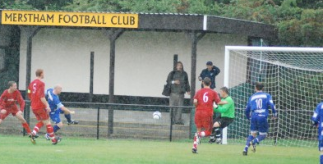
We may not have been here too long, but in our two seasons at Merstham F.C. I can think of a few bits and pieces that I will remember when we move to Chipstead.

Having only been here twice previously, I was very impressed with what I saw that first day. Despite the weather being poor (a typical pattern for home games during 2010/11) the pitch looked great, and the Boardroom was impressive. We even started off with a win as Shoreham F.C. were defeated 3-0 in an F.A.Cup tie. I also recall being stung by a wasp (seen in above picture) just as Mark Jarman opened the scoring during a downpour that accompanied the early period of the game!

Our next match resulted in a 5-0 win over Dorking, finished off by a goal from Tony Cuff direct from a corner that he hit with the outside of his foot!

We didn’t know it at the time, but that was probably the high water mark of our time here. Guildford visited and bashed us up 5-1 and we wouldn’t actually win a Saturday home League game all season.

There were some exciting moments in Cup competitions as Flackwell Heath were also seen off 3-2 before our F.A.Cup run ended at Hythe Town, while a Sunday F.A.Vase game brought in a healthy number to watch us defeat Bracknell Town 4-0 in a downpour.

Then we had the visit of St Neots Town once the snow had relented, but despite an early lead, there was an inevitability about their 2-1 win and our run was over.

Also, the League Cup brought an entertaining set of behind the goal references to Rachel Riley to our encounter with Worcester Park, which had seen us trail before equalising and then going ahead in extra time, only to be pulled back once again. A Terry Fennessey penalty kick was our fifth successful one in a row and earned the win in the shootout. It was a real kick in the guts to then go out 3-1 after extra time at home to Camberley in the January, as we really didn’t turn up that day.

I can recall a Tuesday evening back in February of 2011 when he hosted Croydon, and trailed at half time. Despite equalising early in the second half we then went behind again but through the disappointment I recall saying to Steve Davies next to

me that despite the signs, I had a feeling that we were going to get something from the game. Two great goals from Ramzi Bedj Bedj later we had won 3-2 and the goals are still available on Youtube if you want to see them again.

I can also remember a 2-2 draw at home to Molesey where we were awarded two debateable penalties and our people had to drag their angry Manager away from the referee at the end of the game.

We had a couple of funny moments to cheer. A sliced own goal by an Ash defender brought us a point in October, while a Hanworth defender did much the same in March, although we were still unable to take anything from the game.

Despite our poor record at Moatside that season, it wasn’t until Cove visited on 8th March that he had failed to score in a match there, our nineteenth of the season.

As the season drew to a close, a scorching last minute equaliser from Dale Marvell preserved a point against Bookham and a last minute Neil Harrowing miskick enabled Egham to scrape a point from a 2-2 draw in our final match there.

Our second season here is largely covered elsewhere in my seasonal summary, so there is little point in repeating this.

However, two great goals from Dave Francis gave us real hope against Windsor, as did an Alex McGregor goal against Guildford but neither ended in a win, and it was a season of missed opportunities again as Hanworth Villa also nicked a late point, before Horley got their first win over us with another two late goals.

Even the Surrey Senior Cup match with Sutton produced a disappointing attendance, although we gave them a really good game.

I suppose Dorking will be pleased that they don’t have to come here again as they conceded five in January as they had done on their previous visit, but I think our best performance here this season was the 3-1 win over South Park, who were really flying at the time.

In summary then, not much to write home about, but then, where is home these days?

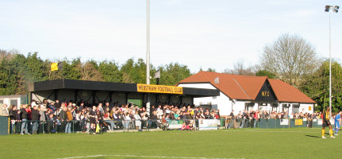

Days Since:
I just thought I’d have a look at some important dates in our club’s history.

Taking an estimated day of foundation as 1st March 1918 (it was definitely in March but exact date unknown), we have been in existence for 34,380 days.

It is 28,632 days since we played in the F.A.Cup First Round against Clapton Orient (25/11/1933).

It is 26,524 days since we closed for World War Two (03/09/1939).

It is 18,979 days since we won the Corinthian League Memorial Shield (30/04/1960).

It is 13,512 days since we appeared at Wembley Stadium in the first F.A.Vase Final (19/04/1975).

It is 11,319 days since we won the Surrey Senior Cup (20/04/1981).

It is 10,212 days since we earned promotion to the Isthmian League Premier Division (01/05/1984).

It is 6,920 days, (or 18 years, eleven months and fifteen days) since we played our last match at West Street (06/05/1993). We will reach the 7,000 day mark on 10th July 2012.

It is 5,109 days since we last reached a Cup Final (21/04/1998 – Associate Members Trophy v Bedford Town).

Scary isn’t it!

Club Record v Camberley Town:
Competition | Played | W – D – L – (Ab) | F – A
Surrey Senior League | 6 | 3 – 2 – 1 | 15 – 8
Surrey Senior Cup | 6 | 4 – 1 – 1 | 26 – 11
Surrey Senior Shield | 1 | 1 – 0 – 0 | 3 – 1
F.A. Cup | 3 | 1 – 1 – 1 | 2 – 2
F.A. Vase | 1 | 0 – 0 – 1 | 1 – 3
Athenian League Division 2 | 2 | 1 – 1 – 0 | 4 – 3
Isthmian League Division 1 | 4 | 2 – 1 – 1 | 8 – 4
Isthmian League Division 2 | 6 | 1 – 2 – 3 | 5 – 12
Isthmian League Division 2s | 8 | 4 – 3 – 1 | 11 – 5
Isthmian League Division 3 | 22 | 9 – 7 – 6 | 39 – 27
Associate Members Trophy | 4 | 3 – 1 – 0 | 11 – 4
Combined Counties League | 12 | 4 – 1 – 6 (1) | 16 – 22
EL Records League Cup | 2 | 1 – 0 – 1 | 3 – 3

Youth Team Fixtures / Results 2011/12
1 | 05/09/11 | Thur | ST ANDREWS | SYL | 1-2 | Matheson
2 | 08/09/11 | Mon | Horsham | FAYC  PR | 2-1 | Smith (pen), Matheson
3 | 12/09/11 | Mon | BALHAM BLAZERS | SYL | 3-2 | Matheson, Smith (pen), Nadesan
4 | 26/09/11 | Mon | COBHAM | SYL | 4-0 | Jones, Matheson, Nadesan, Boyden
5 | 29/09/11 | Thur | Colliers Wood United | SYL | 3-2 | Matheson, Boyden, Bough
6 | 05/10/11 | Wed | Lancing | FAYC  2q | 9-0 | Smith (2, 1 pen), Bryant, Nadesan, Best, Jones, Matheson, Nevin (2)
7 | 10/10/11 | Mon | Egham Town | SMFC 1 | 0-3
8 | 17/10/11 | Mon | EBBSFLEET UNITED | FAYC 3q | 2-3+ | Jones, Smith
9 | 24/10/11 | Mon | Guildford City | SYLC 2 | 3-2 | Jones (2), Best
10 | 02/11/11 | Wed | Bedfont Sports | SYL | 5-2 | Jones (2), Nevin (2), Best
11 | 07/11/11 | Mon | LEATHERHEAD | SYL | 2-0 | Jones, Smith
12 | 10/11/11 | Thur | Crawley Down | SYLC 3 | 1-0 | Nevin
13 | 17/11/12 | Thur | St Andrews | SYL | 5-2 | Nevin (2), Achkar,  Jones, Smith
14 | 21/11/11 | Mon | EGHAM TOWN | SYL | 1-5 | Jones
15 | 01/12/11 | Thur | Leatherhead | SYL | 2-1 | Doyle, D.Smith
16 | 05/12/11 | Mon | EGHAM TOWN | SYLC  QF | 2-2+ | Jones (2)
Lost 4-3 on penalties
17 | 12/01/12 | Thur | Cobham | SYL | 3-1 | Jones, Nevin, D.Smith
18 | 19/01/12 | Thur | Farnham Town | GM 2 | 3-2 | D.Smith (pen), Best (2)
19 | 30/01/12 | Mon | HANWORTH VILLA | SYL | 2-0 | Nadesan (2)
20 | 27/02/12 | Mon | BEDFONT SPORTS | SYL | 3-1 | Achkar, Boyden, Jones
21 | 01/03/12 | Thur | Hanworth Villa | SYL | 0-1
22 | 08/03/12 | Thur | Cobham | GM QF | 6-1 | Ashcroft (3), Banks (2), Nadesan
23 | 12/03/12 | Mon | COLLIERS WOOD | SYL | 5-1 | D.Smith (2), Nevin, Jones, Banks
24 | 19/03/12 | Mon | Knaphill | GM SF | 0-1
25 | 22/03/12 | Thur | Egham Town | SYL | 0-1
26 | 26/03/12 | Mon | MOLESEY | SYL | 2-0 | Best, Jones
27 | 29/03/12 | Thur | Balham Blazers | SYL | 2-2 | Boyden, Nadesan
28 | 11/04/12 | Wed | Molesey | SYL | 6-0 | ??
29 | 23/04/12 | Mon | WESTFIELD | SYL
 | tba | Mon | Westfield | SYL
SYL - Southern Youth League FAYC - F.A. Youth Cup
GM – Grant McLellan Youth Cup
SYLC - Southern Youth League Cup SMFC - Surrey Midweek Floodlit Cup

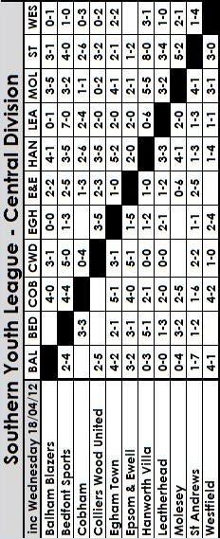

Southern Youth League Table
Inc Wednesday 18th April | P | W | D | L | F | A | Pts | GD
Egham Town | 18 | 14 | 3 | 1 | 51 | 22 | 45 | +29
Epsom & Ewell | 18 | 13 | 1 | 4 | 49 | 24 | 40 | +25
Hanworth Villa | 20 | 10 | 3 | 7 | 55 | 47 | 33 | +8
Balham Blazers | 18 | 9 | 3 | 6 | 47 | 28 | 30 | +19
Westfield | 17 | 9 | 2 | 6 | 33 | 23 | 29 | +10
Leatherhead | 20 | 8 | 4 | 8 | 31 | 34 | 28 | -3
Bedfont Sports | 17 | 7 | 2 | 8 | 45 | 41 | 23 | +4
Molesey | 18 | 7 | 2 | 9 | 39 | 49 | 23 | -10
St. Andrews | 20 | 4 | 2 | 14 | 33 | 68 | 14 | -35
Colliers Wood Utd | 17 | 3 | 3 | 11 | 24 | 43 | 12 | -19
Cobham | 17 | 2 | 3 | 12 | 30 | 58 | 9 | -28

Grant McLellan Youth Cup
Semi Finals
Knaphill | 1-0 | Epsom & Ewell
Bedfont Sports | 26/4 | Camberley Town

Suburban League Southern Division Table
Inc Monday 16th April | P | W | D | L | F | A | Pts | GD
Walton & Hersham | 24 | 21 | 0 | 3 | 66 | 23 | 63 | +43
Thamesmead Town | 22 | 15 | 4 | 3 | 73 | 36 | 49 | +37
South Park | 23 | 14 | 2 | 7 | 77 | 52 | 44 | +25
Epsom & Ewell | 24 | 13 | 4 | 7 | 60 | 42 | 43 | +18
Crowborough Ath | 24 | 11 | 6 | 7 | 62 | 53 | 39 | +9
Corinthian | 23 | 11 | 4 | 8 | 53 | 46 | 37 | +7
Lingfield | 24 | 10 | 4 | 10 | 61 | 67 | 34 | -6
Molesey | 24 | 8 | 8 | 8 | 44 | 47 | 32 | -3
Cobham | 23 | 7 | 3 | 13 | 43 | 63 | 24 | -20
Mole Valley SCR | 25 | 7 | 2 | 16 | 42 | 68 | 23 | -26
Oakwood | 22 | 6 | 4 | 12 | 39 | 60 | 22 | -21
Chessington & Hook | 23 | 4 | 7 | 12 | 39 | 48 | 19 | -9
Redhill | 24 | 5 | 4 | 15 | 44 | 74 | 19 | -30
Horley Town | 21 | 3 | 4 | 14 | 33 | 57 | 13 | -24

2nd XI Fixtures / Results - 2011/12
1 | 22/08/11 | Mon | MOLESEY | SL | 2-3 | Matthews, Hughes
2 | 27/08/11 | Sat | Thamesmead Town | SL | 1-1 | Hughes
3 | 03/09/11 | Sat | Hanworth Villa | SLC 1-1 | 3-4 | Williams, Harmsworth, Okolie
4 | 17/09/11 | Sat | South Park | SL | 2-2 | Adewale, Hagan
5 | 19/09/11 | Mon | CHESSINGTON & HOOK UNITED | SL | 4-1 | Alsanawi (2),  Gough, Pangisban
6 | 24/09/11 | Sat | Oakwood | SL | 5-0 | Binns (2), Alsanawi, Matthews, Hughes (pen)
7 | 26/09/11 | Mon | Redhill | SL | 4-4 | Adewale, England (pen), Martin, Gough
8 | 03/10/11 | Mon | LINGFIELD | SL | 2-1 | Hughes, Matthews
9 | 08/10/11 | Sat | Corinthian | SL | 6-1 | Hughes (2, 1 pen), Tilly, Flack, Dewar, Bassaka
10 | 12/10/11 | Wed | Mole Valley SCR | SL | 4-0 | Williams, Tilly, Hughes, Allan
11 | 24/10/11 | Mon | WALTON & HERSHAM | SL | 3-0 | Dewar (2), Richards
12 | 05/11/11 | Sat | Crowborough Ath | SL | 4-2 | Hughes, Williams, Francis, Matthews (pen)
13 | 14/11/11 | Mon | COBHAM | SL | 5-1 | Francis (2), Stephens, Hughes, Alsanawi
14 | 19/11/11 | Sat | Horley Town | SL | 2-1 | England, Alsanawi
15 | 28/11/11 | Mon | HANWORTH VILLA | SLC 1-2 | 2-1 | Hughes (pen), Matheson
Aggregate 5-5 – Lost 4-2 on penalties
16 | 03/12/11 | Sat | Chessington & Hook | SL | 1-0 | Matthews
17 | 28/01/12 | Sat | Walton & Hersham | SL | 1-2 | McGregor
18 | 18/02/12 | Sat | Molesey | SL | 2-1 | Matheson, Nevin
19 | 20/02/12 | Mon | OAKWOOD | SL | 1-2 | Jarman
20 | 22/02/12 | Wed | Met Police | SLS | 1-4 | McGregor
21 | 05/03/12 | Mon | CROWBOROUGH ATHLETIC | SL | 1-3 | Gough
22 | 14/03/12 | Wed | MET POLICE | SLS | 2-5 | Nadesan (2) @ Imber Court
23 | 17/03/12 | Sat | Cobham | SL | 3-0 | Adewale, Martin, Russell
24 | 19/03/12 | Mon | THAMESMEAD TOWN | SL | 2-4 | Martin, Russell
25 | 31/03/12 | Sat | Lingfield | SL | 0-9
26 | 02/04/12 | Mon | SOUTH PARK | SL | 1-2 | Tilly
27 | 07/04/12 | Sat | REDHILL | SL | 4-2 | ??
28 | 16/04/12 | Mon | CORINTHIAN | SL | 0-0
29 | 19/04/12 | Thur | HORLEY TOWN | SL | p-p
30 | 30/04/12 | Mon | MOLE VALLEY SCR | SL
SL - Suburban League SLS – Suburban League Shield
SLC - Suburban League Cup

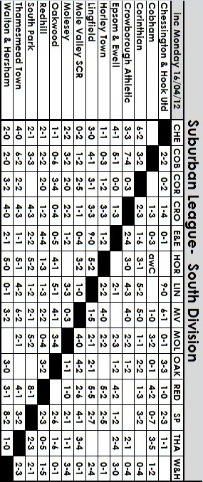

My Seasonal Summary

In covering a summary for the season you would usually start at the beginning and I will do so shortly, but the biggest talking point was the six-point deduction that the club received in January for playing two players who were suspended through an accumulation of bookings at the time.

Paul West and Alex McGregor were the players concerned, although the fault was not theirs, and it was typical that the two offences occurred in games that we won, against Croydon (2-1) and Banstead (1-0) respectively.

Yes, of course we were fined too, but had we lost those games, we wouldn’t actually have lost any points. We only lost the points we won, which opens up a real potential can of worms. For starters, why isn’t every team penalised the same for the same offence? It also occurred to me only a week or two back that whilst we had received the deduction, our goal difference had remained untouched.

Now, Croydon not only lost to us, but back at the start of the season they were also beaten 4-0 by Hanworth Villa who also played an ineligible player. It is just as well they aren’t battling to stay up on goal difference. Likewise for Banstead, whose difference should technically be one better, although it is of little help to them now!

So, I am starting my summary with the Worst Decision category, and whilst there have inevitably been some bad ones by officials and players alike, not least the short notice postponement of the Molesey match in January, because it was “a bit chilly”, it could be argued that this decision by the League is actually the worst, and one to keep an eye on in the future if we ever get into a tight relegation battle.

Anyway, back to the start of the season. It was clear at the start that we were going to need some time to settle in following the departures of Kyle Hough to Horley, and Dale Marvell and Paul Borg to Egham, all massive losses. However, goal scoring machine Robbie Burns was back and as long as we could get him the service, I felt we’d be fine, especially when I had heard that we were bringing in players at the back too, like Dre Grobler who had played really well against us the previous season, and Jamie Summers, one of a crop of quality youngsters from Kingstonian who would serve us well.

The season started well with a 2-1 win at Cove that was far more convincing than the score line suggested as they reduced the deficit with a late penalty. There was nasty brawl at the end of the game that saw a Cove player sent off. In fact Alex Rodrigues received stitches for a cut as a result of trying to break up the trouble, and this led to our substitute keeper Dan Coles making his debut for us as an outfield player!

A slight wobble in the middle of the next match against Colliers Wood United was settled by a screaming 30 yard strike from Chris Woodward, signed from Bookham, and although he would soon return there, it was the only memorable moment from our 3-1 win.

Our great start to the season continued as we hosted pre-season favourites, the newly formed Windsor, and led at half time by two goals to nil. However, an early penalty for Windsor and an equaliser soon after ensured a nervy last twenty minutes, although we did look the more likely to score in that period.

Which is more than can be said for the game at Farnham Town. On a lovely August Tuesday evening the spectators were treated to 88 minutes of tepid action, only enlivened at the end by a goal line block from both sides as the game wound down.

The Farnham match was the last game played by Alex Rodrigues in his ever-present run that ended at 188 as he went on holiday. Without him, we then conceded just 25

seconds into our Sunday F.A.Cup game against Croydon before fighting back to win 3-1, although a missed penalty did help us.

Unfortunately two days later my concerns came true as our unbeaten League run ended against Guildford City. I had pushed our people to move this game back to the Wednesday, based on the fact that our players would have a day less to prepare than Guildford, but nothing was done and Alex McGregor put us 2-1 up with twenty-five minutes to play, only to concede twice in the final stages as we ran out of steam.

Normal service was resumed with a 3-1 home win over a very poor Mole Valley SCR side. It was also nice to win a home league match on a Saturday, something we had failed to do for the whole of 2010/11! However, for the second time in a week we then saw another 2-1 lead turn into a late 2-3 defeat, this time at Raynes Park on the Bank Holiday morning.

Our F.A.Cup run came to a predictable end against Step Four Chipstead, although we ran them close, and when we were matched against Step Six opposition in Hailsham Town a week later, again it was the senior of the teams that came through, although a comfortable 2-0 lead turned into a nervy 2-1 ending, only settled when Matt Harmsworth came on and scored a late winner on his debut.

It would be his only goal for the club though, and a week later Robbie Burns would score his 97th and final goal with a classy back flick against Sandhurst before departing to Chessington & Hook of all places. Despite conceding eight the week before, Sandhurst fought back in the second half to win 3-1 and our excellent start of two wins and two draws had now had three defeats tagged onto it.

It got worse as an injury crisis started to bite, and even though Mark Jarman returned to the team following a sending off against Windsor, he and Burns got no service at all as we were defeated 2-0 by a very good Ringmer side to end our Vase hopes for another year.

October came in with a mini-heatwave and a rearranged fixture sent us to Molesey. On paper this looked tough, but we coped well and two second half goals from Jarman and Matt Smith after great work from Ramzi Bedj Bedj clinched the points.

Somehow we then beat Knaphill 3-2 on the Tuesday as we opened our League Cup campaign. This was an incredible score line though, as I’ve not seen us dominate a game more in my thirty years watching Epsom. We had seventeen attempts on goal in the first half alone, yet the hosts scored on almost their only two ventures out of their half and it required a late, slightly fortunate winner from Nathan Ayling to avoid the extra period.

Our next two games were drawn. At home to Hanworth Villa, we expected the worst as the in-form visitors, still in the F.A.Cup, scored early, but we led by half time and were unlucky to concede an equaliser towards the end. At Dorking we again failed to hold on to a lead as Antony Myers scored, and then was penalised for a penalty and sent off for his reaction. The referee wasn’t finished, sending off Grobler at the end, having dispatched a Dorking player ten minutes from time as well. Both of ours were harsh and in the end it was a horrible evening, despite Dorking being in good form at the time.

We then turned in one of our better displays of the season as we crushed Ash United 4-1 at Shawfields Bedj Bedj was in his element, although two goals in a minute after already having a Carl Downs goal wrongly ruled out for offside when he hadn’t made a pass, killed this game off as a contest.

It was therefore something of a surprise when we then crashed 4-1 at Wembley a week later. Despite the Salts dominating possession, Wembley had three shots on target and a wind-assisted cross and they all went in. Things went from bad to worse as Horley recorded their first ever win against us, while Badshot Lea and Camberley then defeated us, all of which were without registering a single goal.

One bright point during this spell had been the form of new player Sam Robinson and his

finest hour in Epsom colours came on 12th November when we defeated South Park 3-1 at Moatside. They were still in the Vase, but were never in it here and only secured a late consolation in reply to Robinson’s two goals and a delicate looping header from Jarman. We followed this up with an edgy 2-1 win over Croydon in a League match. However, as I advised earlier, West’s participation meant that the points would eventually be removed.

A very creditable 1-0 defeat at Windsor followed, which showed that we could compete against the top teams. Robinson hit the post and Dan Coles played a blinder in goal for us but we were a little unfortunate in the end not to have something to show for it.

Coles had come in for Adrian Jones following the latter’s injury against Guildford back in August and had been our most consistent performer. However, our next game was the prestigious Surrey Senior Cup tie against Sutton United and the now fit Jones was put straight back in without even having played a reserve match. Coles had done really well against Windsor and kept the score down against Egham who had thrashed us 4-1 at Moatside, but his benching for the Sutton game was a real shock and Coles obviously felt the same way and was gone within a fortnight, eventually turning up at Dorking.

Jones was still rusty and although he did nothing wrong against Sutton, who eased through by a goal to nil, he amongst others were guilty of a collective absence of responsibility at Chalky Lane. Epsom led 4-1 at half time, dominating the game and James Cottee had scored his first two goals for the club, although the pick of the bunch was a Matt Smith low drive from the edge of the area that the keeper never got close to.

Chessington reduced the arrears shortly after the restart but we went 5-2 up soon after and looked likely to score many more. However, the substitution of the injured Rodrigues induced panic at the back as the hosts scored three times in the final fifteen minutes to force our first 5-5 draw since 1938!

A poor show at home to Cove was followed by a 1-0 win at Banstead that didn’t count because of the ineligibility of McGregor and the season really slumped with a 4-1 defeat at Step Six Worcester Park in the League Cup. Robinson was only a substitute after being away for a week, and his frustration showed as he picked up two yellow cards in quick succession and the Worcester Park dressing room door then became another victim. He remained with the club for a week or two after this but soon left for Faversham Town.

I found out about the points deduction on Saturday 14th January and we all knew that this meant we’d have to work harder. To the players’ credit, they did. We defeated Wembley by a goal to nil, finally getting one over on their keeper, Lee Pearce, who had beaten us regularly whilst with Bedfont Green, Egham and Wembley previously. Following this a late goal from substitute Jarman earned a 2-2 draw at the Croydon Arena.

We followed up with a 5-0 win over Dorking which would have been more had it not been for our former keeper’s exploits in keeping the score down. As has been the case so often in recent years though, bad weather seems to come when we are on a good run, and we had to wait three weeks to play again.

When we did, we played well at Horley and were the better side for 44 minutes until Jones brought down a Horley player and was harshly sent off by a referee that struggled with the most basic of decisions on the day. We crashed 3-1 in the end with former player Hough scoring two of them and a poor performance at home to Sandhurst allowed them to leave with a narrow 3-2 win, despite having conceded eight again the week before!

As the points deduction finally appeared on the League table we faced three very tough looking fixtures and I was concerned as we travelled to South Park on a Tuesday night. However, despite the absence in midfield of Carl Downs, Ben Hayward re-appeared for the first time in a while and he and Ayling ran the show. Cottee set the ball rolling with a fantastic goal in the first twenty minutes and he got the second with a header soon

afterwards. Jones saved a penalty and we hung on, securing the points with a late Jarman finish.

We got better still at Hanworth Villa, smashing them 3-0 in a game where we competed from first to last. Cottee finished off a good move just before the break, but a great strike from Downs and late penalty from Matt Smith sealed our best performance of the season.

It then came as a bit of a shock as we crashed 6-0 to Molesey at home. We bounced back though with a good 4-2 win at Mole Valley SCR who had been making a run for survival at that point, but whenever we returned to the Moatside things were decidedly average. A 2-0 defeat to an Ash side we had destroyed earlier in the season was hard to take but this was followed by a 4-1 defeat to Farnham Town and after an eleven day break we created little in a desperate 1-0 defeat at home to Chessington & Hook.

This had me worried, but clearly the players were too and they responded with two good fighting draws from Badshot Lea and Guildford City, and on Easter Monday a one man show from Cottee gave us the points with a 2-0 victory over Banstead.

So what were the highlights and lowlights?

Best Performance: Quite clearly our 3-0 away win at full strength Hanworth Villa. Every single player in the team played well.

Runners-Up: Our 4-1 win at Ash United, our recent 2-0 win at Egham, our two wins over South Park, our narrow defeat at Windsor and our battling draw at Guildford.

Worst Performance: Our 4-1 League Cup disaster at Worcester Park. The draw had opened up really well for us, and as it turned out we wouldn’t have had to play a side above us to reach the Final.

Runners-Up: Our two matches with Chessington & Hook, and our 6-0 home defeat to Molesey, but some other home defeats could have gone in here.

Best Save: Dan Coles, a close range double save at Windsor in November. Brilliant.

Goal of the Season: Runners-Up:

Robbie Burns – his first goal v Hailsham (A) – controlled cross in an instant and then danced around the keeper, leaving him on his backside before rolling it in.
Mark Jarman – his second goal v Ash (A) - Great work from Bedj Bedj who set him up for a low drive into the corner
Matt Smith – both his goals v Chessington & Hook (A) – the first was a low drive from just outside the area, and his second when he got in front of a defender to finish off Ayling’s pinpoint cross.
Mark Jarman v Dorking (H) – Finished off a great run by Cottee that split the opposition.
James Cottee v Hanworth Villa (A) – Finished off a great move involving Downs and Ali Dewar with a shot into the corner
Carl Downs v Hanworth Villa (A) - Great strike from outside the area.
Martin Grant v Guildford City (A) – Held off his man well then turned and hit a curling shot into the corner from the edge of the box, giving the keeper no chance.
Ben Hayward v Banstead Athletic (H) – Finished off a great run by Cottee similar to his one against Dorking, but from the other wing.
Goal of the Season: Top 3:

3) Chris Woodward v Colliers Wood (H) – A swerving 30 yard strike. Unstoppable.
2) James Cottee v Banstead Athletic (H) – Took pass from Jarman in his stride, sidestepped a challenge and clipped the ball over the keeper with his right foot from a narrow angle.
1) James Cottee v South Park (A) – Cut in from the right, avoiding challenges and curled the ball into the top corner with his left foot from twenty yards.



Alan Carter’s 9 at Half Time – Quiz 23

Al’s 9 at half time – Quiz 23

For those of you looking for something to do whilst you sip your half time “cuppa” and wait for the action to resume why not have a go at my 9 at half time quiz?

Even if you don’t know the answers at least you’ll end up with a juicy tit bit to tell your mates down the pub.

1. Name two of the four players who won full England caps while playing for German clubs?

2: Which country holds the record for the most failed FIFA World Cup Finals qualification attempts?

3: Who are the only team to have been relegated from the Premier League four times?
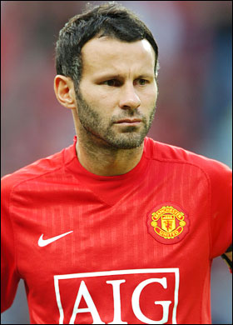
4: Who was the only Top Flight highest goalscorer to achieve the feat with three different clubs?

5: How many Premier League titles has Ryan Giggs won with Manchester United?

6: Who was the first English player to win League Championships in three different countries?

7: How many past & present Football League clubs had an "X" in their name?

8: Which was the only FIFA World Cup Finals Tournament that failed to produce a single hat-trick?

9: Which club has played in the Top Flight of English football the most seasons without ever winning the Championship?

Answers on page 51 – I got 1 – Embarrassed Ed!

This page for appearances spreadsheet (centre pages)

This page for appearances spreadsheet (centre pages)

Club Statistical History
Full Club Historical Record (up to date):

League: Played: 2,675, Won: 1,074, Drawn: 512, Lost: 1,083, Ab: 6

For: 4,878, Against: 4,795, Goal Difference: plus 83

Other: Played: 1,054, Won: 502, Drawn: 119, Lost: 431, Ab: 2

For: 2,302, Against: 1,970, Goal Difference: plus 332

Total: Played 3,729, Won: 1,576, Drawn: 631, Lost: 1,514, Ab: 8

For: 7,180, Against: 6,765, Goal Difference: plus 415

First Senior Match: 30th August 1924.
Lost 1-3 v Dorking at our home ground at the time of Horton Hospital Grounds.

First Match Programme Issued: 15th September 1923.
Won 4-0 v West Norwood Reserves - Friendly match at Horton Hospital Grounds.

Number of Official Home Grounds: Five.
Alexandra Recreation Ground 1918-1922, Horton Hospital Grounds 1922-1925,
West Street 1925-1993, Merland Rise 1993-2010, Moatside 2010 - present.

Record Win: 12th October 1935.
13-1 v Reigate Priory at West Street in the Amateur Cup.

Record Defeat: 14th February 1948.
14-0 at Chelmsford City Reserves in the London League.

Longest Serving Manager: 1) Adrian Hill 1982-1985 and 1990-2003
2) Pat O’Connell 1973-1982
3) Lyndon Buckwell 2006-present
4) Ricky Kidd 1986-1990

Record Appearances: 1) Graham Morris 658 1990-2004
2) Nigel Bennett 630 1989-2005
3) Tommy Tuite 582 1973-1987

Record Goal Scorers: 1) Tommy Tuite 391 1973-1987
2) Reg Marlow 254 1924-1936
3) Jimmy Jones 148 1933-1945

Most Appearances in a season: Tony Coombe and Tommy Tuite - 59 in 1980/81.

Most goals in a season: Reg Marlow - 65 (at least) in 39 appearances in 1926/27

Senior League Titles: 5 - 1925/26 Surrey Senior League - 1926/27 Surrey Senior League - 1927/28 London League - - 1974/75 Surrey Senior League - 1977/78 Isthmian League Division Two

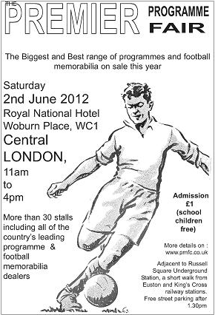

Meet the Editorial Team

Steve Davies

Steve has been supporting the club for many years, starting out with occasional games in the 1973/74 season. He had a spell away with Eastbourne United, where he became Treasurer and Chairman while they were in the Isthmian League, but returned to the Blues in the mid-nineties and has been a regular ever since.
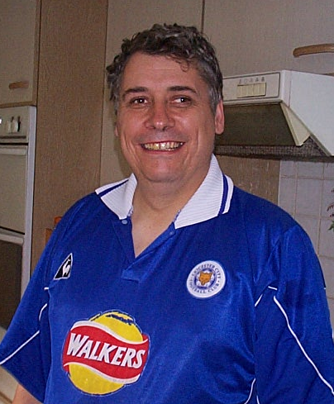
Steve Dyke

Steve has been a supporter for almost as long, following his father and long-term supporter, Wally up to West Street. With exception of his student years, he has been a regular since 1974/75, and recalls his first real memory being at Wembley for the F.A.Vase Final against Hoddesdon.


Alan Carter

Alan is a newer recruit, having supported the club since 2008 He started by going to both Epsom and Banstead home games, before eventually seeing sense and watching us! Before then he was a Wimbledon season ticket holder from 1995-2002 before their move. Since joining the team in 2010 has delighted us with various “Top Tens” and has this season added to his repertoire with the half time quiz, and has also recruited a couple of occasional columnists, his son Jimmy and daughter Louise.

Evan Gregory

Like Alan, Evan has converted from being a regular follower of another club, in his case, Carshalton Athletic. Originally an occasional columnist, he has become part of the regular team, and his surreal take on, well, pretty much everything, has provided another angle to our team of contributors. Our very own Stuart Hall, but without the maniacal laughter!

Gemma Jarman

Gemma has been providing photographs for the programme on a regular basis since her son Mark joined the club from Bookham in 2009. “Team Jarman” is comprised of Gary, Jack and Lauren who are regulars at our games, while Lauren has also proved to be a very competent substitute photographer on the rare occasions that mum is absent. While articles are wonderful, if you don’t get a photo of a game then that moment is lost forever except in the eyes of the few that saw it, and the club is very thankful that we have a massive library to look back on.

Lyndon Buckwell

Already well-known as our Manager since October 2006, Lyndon has this season been a regular on our very own Page 3, providing an insight into what goes on behind the scenes.

He has also kept us up to date with player moves, both in and out of the club and injury updates.

Richard Lambert – Editor

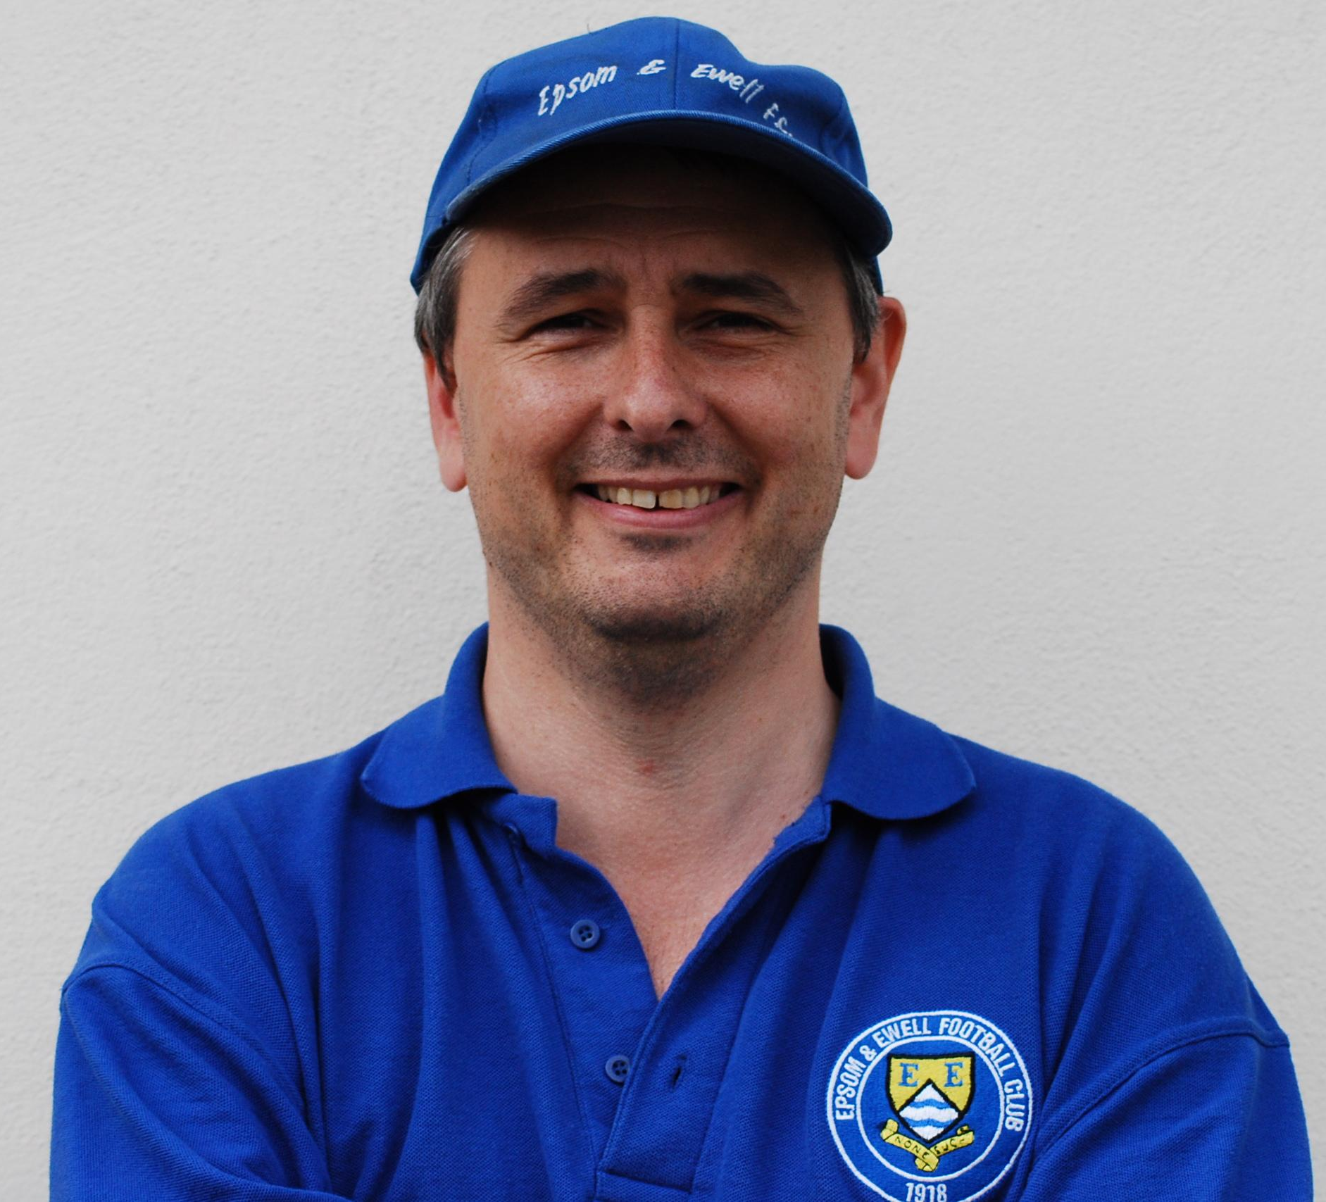

Richard has just passed his thirty-year mark as a supporter, and went for over thirteen years without missing a game between 1982 and 1995, finally completing another ever-present season this year. Has instigated various fund-raising initiatives over the years, including four sponsored walks and selling old programmes on eBay. He is also the main contributor to the club website, but would appreciate some help! He has now completed his fourth season as Programme Editor and would like to think we have kept you all as entertained as you were with last season’s double award winning issues.

He is also Club Historian, being responsible for Two Legs Not Four, a 350 page club History that is now sold out and very rare.

If anyone else wishes to add ANYTHING to the programme, or even wishes to write a regular column, I am interested. Please let me know either at a game, or by email on richard.c.lambert@virgin.net

To Tweet or not to Tweet, that is the question!
Follow us on Twitter

Remember that you can follow us on Twitter. Just go on to http://twitter.com/EEFCWebmaster#l Alternatively, go to twitter.com and search for eefcwebmaster or Epsom and Ewell FC. You can then "follow us" (if you have a Twitter account).


As I write, we currently have 263 followers including Surrey Mirror Sport and the Surrey Advertiser, plus a number of clubs from our Division. In addition Radio Marsden update their listeners on our progress on match days thanks to our goal updates service (see below).

Goal updates

Get Epsom & Ewell goal updates sent direct to your mobile phone by signing up to receive text messages from Twitter (if your mobile phone is compatible).

Alan Carter and Richard Lambert are providing a First Team live score update service, whenever possible, meaning that texts will be sent to your mobile phone as the goals happen.

Go on, give it a go and join in the fun! Let's see if we can get our followers up to 300!

To receive alerts to your mobile phone

1. Log into, or set up, your Twitter account and register your mobile phone.
2. Click on “Home” in the top menu bar
3. Click on “Following” at the top of the right-hand column.
4. Click on EEFCWebmaster and you will see in the left-hand column, a mobile phone icon next to the “Following” box. Click on that and you will be set up to receive Epsom and Ewell FC “tweets”. On the facing page is an excerpt from our Twitter page.

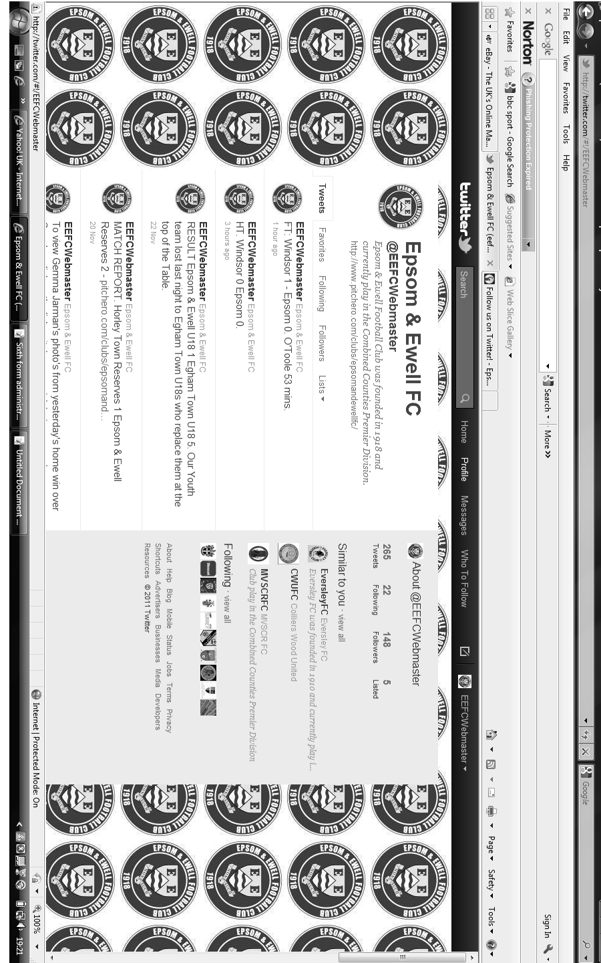

Steve Dyke
Talking to that ref really cheered me up

This may well be the last of these little columns as I believe we are seeking a leaner more focussed programme for next year. Also in the short lived “which part of the programme do you wish to retain” poll, 309 less people voted for my column than for the hapless Labour Candidate in Stamford ward last May so I can hardly bow out on the old showbiz maxim of leave them wanting more.

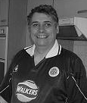
So what have I learned during the three years of this column? I’ve learned how to give the programme editor kittens by scraping in just ahead of each deadline, and how to hit just about two pages each time whilst sharing my reflections on the highways and byways of football.

During that time I have become a committee member as well, which gives a new perspective on all the voluntary tasks that are done to get a game on. There are many. That is in addition to the responsibility of making decisions to take our club forward in the difficult position we are in of having ground shared for nearly two decades.

Being a committee member means that at times I have had to leave some aspects of fandom behind. I am now much easier on referees (Ha! – Ed) because when you look at it they get most of the decisions right and within a spell of the end of the match we need to be socialising with them. You also have to shake the opposition committee by the hand and say well done – often through gritted teeth if the game has been particularly controversial.

There has been a spell during our recent run of home defeats to moderate opponents where my duties have involved covering the boardroom hospitality and this has meant spending large parts of each game washing up. In the case of the Ash and Sandhurst games that was probably more entertaining than the game.

As others will probably also write, this has been a bit of a frustrating season. Although we ensured mathematical safety with our win last Saturday a mixture of administrative slip ups and poor performances lead us unnecessarily into the relegation scrap for a spell. Yet if we win these last two games and we end up with a point more than last year – even with the minus six points.

Now I’ve been watching this club a long time and I’ve seen some poor teams. A young team shorn of its best players going to Croydon Athletic (remember them!) were out of our depth in Ryman One South and we finished bottom. I kept coming every week and there were no complaints from me because I accepted the situation.

The situation before Lyndon joined us was bleak with a young team struggling and letting bucket loads of goals in. What he did in his first season in pulling us up into mid table laid the foundations of the better seasons to follow and maybe we grew to thinking we would always be one of the better sides in the

league .

The team this year, despite missing some of our better players from recent years - nice to meet and beat most of them again at Egham last week - is not a bad team that should be fighting relegation. The big frustration is that in some of the games we have shown flashes of our potential. The draw at Guildford and the wins at Hanworth Villa and Egham have shown that we are at times not far of being a very good side.

The flip side of this is during the recent run of home defeats and at other times –Worcester Park away, Camberley away we have been shocking.

Nothing illustrates the schizophrenic nature of our season better than the 5-5 draw at Chessington. Our attacking play that day was awesome as we put them to the sword. At 5-2 up wave after wave of attack came towards us and we looked sure to score 10 or 12. The late collapse to 5-5 is well known about and little more needs to be said about it – but it was all there in one game.

So the home return with Chessington a couple of weeks ago. We had sunk to the fringes of the relegation battle and they were five points beneath us. Surely we would be motivated to put then to the sword and get ourselves nearly safe in the process?

It didn’t happen. Now I support all the team no matter who is out there but my supporters heart sank when James Cottee was left on the bench, as to me his goals, form and potential are one of the real plusses of this season. The limp performance creating one chance until a bit of a heave in the last five minutes was dismal My fatalism kicked in – some of our friends were watching the game as sponsors and we always play crap when I get people along.

In the committee room afterwards I did all the usual thanks and well done’s to the Chessington contingent but man was I feeling down. We were in serious relegation trouble now.

My next committee duty was to entertain the match officials for a drink in the boardroom. I sat down with them. The ref was happy because there had not been a single booking in the game and he thought that reflected he had handled it well. I was still a bit grumpy because of our performance and thought a booking for a crunching challenge might have been welcome as a sign we were more up for it. The ref said he thought we had played quite well - I disagreed.

It did make me think that our Player discipline has improved as the season has gone on. Now some of that is due to a change of personnel, but our conversation got round to the South Park game where we held our discipline better than they did and it got us a point and it was something I was quite concerned about earlier in the season.

It has cost us a lot of penalties, and some sendings off in important games too (Ringmer).

Talking to that ref really cheered me up!

Every Opponent A-Z
Over the years we have played many, many different opponents. Exactly how many is a difficult question, as it all depends on your definition. Are Camberley & Yorktown different to Camberley Town, or are Epsom Town different to Epsom F.C. or Epsom & Ewell F.C.?

In my analysis I have classed them as the same team, and will work through them all from A to Z. Some we have played many times, whilst others we have met maybe just once or twice. Enjoy!

Guildford: Played 14 - W11 D3 L0 - F64 A17 - Points per Game - 2.57 – Fantastic
Ewell v Guildford: Played 15 - W4 D2 L9 - F22 A30 - Points per Game - 0.93 - Poor

We complete this season’s segments with a look at the County town of Surrey, but as this particular team also go back to the days of our main forerunners Ewell F.C. I shall cover a bit on each era.

Always a hot bed of football the original team, the Guildford Pinks as they used to be known were very successful and played at a few grounds. The first of these was at the original Guildford Cricket ground, which was situated near to where the current Law Courts are now. These were developed in the early 1890’s and they moved with the cricket ground to Woodbridge Road, where the cricketers still remain.

Ewell F.C. first travelled to Woodbridge Road on the 3rd March 1894 but they didn’t play Guildford. In fact they weren’t eligible to play them as Ewell were only a Junior status side back then, but this match was the Final of the Surrey Junior Cup.

This competition carried with it a status slightly higher than the Surrey Intermediate Cup does today. It wasn’t large but it was certainly something of importance and Guildford’s ground was the venue of choice for the Surrey F.A. back then and held all the finals. However, Ewell were far too good for this level and Balham Wanderers were destroyed 6-0, which remains the largest ever victory margin in this competition with a hat trick from Ted Perks another from his brother A.Perks and two from the club’s talisman Alex White.

As a consequence of winning this competition Ewell became a Senior status side and would be able to enter the Surrey Senior Cup alongside such illustrious names as West Croydon, West Norwood, Weybridge, Dorking, Reigate Priory and of course Guildford. And it was in that competition that the clubs first met on 30th November 1895. We led 2-0 at half time but lost 2-3 at Woodbridge Road and although the protest that followed on the eligibility of one of the Guildford players was upheld, we lost a replayed match at West Street in January of 1896 by three goals to one.

Ewell were a good side back then but Guildford often seemed to have their number and won the first four meetings between the sides before we defeated them 4-1 at Ewell in November 1896. Our best win over them came in the Surrey Charity Shield on 12th February 1898 when a Barry Porter goal enabled us to progress, eventually reaching the final that season. In 1899 Ewell reached the Final of the Surrey Senior Cup, losing 2-0 to Weybridge but the bubble burst soon after and the club went into decline, finally folding midway through the 1904/1905 season.

Guildford themselves remained a solid but unsuccessful side, surprisingly for a town of their size only reaching the Surrey Senior Cup Final on one occasion, losing 4-0 to West Croydon at Kingston’s Dinton Road ground. By 1920 a new kid was on the block in Guildford United who would shortly afterwards name themselves Guildford City and have much success as a professional outfit for the next fifty years.

This of course had a knock on effect on the older but smaller club and they arranged a ground share at the newer Josephs Road ground for a period in the twenties. This was where our current club first met them as members of the Surrey Senior League in 1924/25. We won all three home League games during our spell in the League, one of which was a 10-3 annihilation with Reg Marlow scoring four times, and the following season we beat them 7-3 with hat tricks for Jack Parr and for Marlow again, yet we couldn’t win any of the three games in Guildford, drawing two and losing the other by four goals to one.

We moved upwards into the London League in 1927 and Guildford remained in the Surrey Senior League for many years, even meeting Ewell & Stoneleigh during their brief two year existence just before the war.

Upon resumption after the war they continued in the Surrey Senior League and we met for an F.A.Cup tie in September 1949, winning easily 6-0 and again in the Surrey Senior Cup in October 1952 when we won 7-0 with Bill Goddard scoring five times. By this time though they were struggling as the post war boom at clubs like their big neighbours was killing them off. In 1951/52 and 1952/53 they finished bottom of the Surrey Senior League and in May 1953 we met for last of our occasional post war friendlies labelled as the Sportsman’s Cup. Goddard scored four more times as we destroyed them 10-1 at West Street, and to my knowledge this game on 2nd May 1953 was their last ever match.

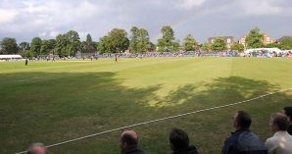
How ironic that at the time of football’s greatest ever burst in spectator interest, such a club had to fold due to lack of support. Of course twenty five years later their bigger brother would go the same way but that’s another story for another season!

Woodbridge Road, home of Guildford F.C. for many seasons, a long time ago

Alan Carter
I’m going to buck tradition this year and pass on my end of season review.

Normally I compile a list of my Top Ten moments of the season. Unfortunately it has just been one of those campaigns which ended up with a brief relegation scrap. However, if I was compiling a top ten list then my favourite moment would have been our second goal scored by Ben Hayward against Banstead on 9th April.

As you can see from the photo, having scored Ben stood his ground with his arms aloft as the supporters in the stand celebrated and my kids did a “Barry Fry” behind the goal.

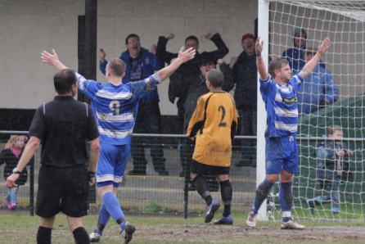
Unfortunately I missed all of October and November this season due to Glandular fever (Wuss! – Ed and Ian T). What got me through this period was our Twitter feed. Richard would text me the scores and I would tweet them. Instead of being at a game I would be sat in front of my laptop checking on the scores at other CCL games whilst waiting for hopefully good news with which to update our followers.

What has been really pleasing this season for me personally has been seeing our twitter presence grow. At the start of the season we had less than 50 followers and at time of writing we are up to 263 and hoping to get to 300 by the end of the season.

Despite our impressive progress, as you can see from my CCL Twitter league table below we have a long way to go to catch up with some other teams.

So go on, persuade your mates to follow us and help us boost our twitter numbers. Hopefully next season we’ll then be higher up the Twitter league table as well as higher up the CCL Premier Division table.

Twitter League (number of followers as at 12/4/12)

Position | Team | Followers
1 | Guildford City | 1,518
2 | Camberley Town | 1,074
3 | Wembley | 582
4 | Chessington & Hook United | 562
5 | Croydon | 559
6 | Windsor | 500

7 | Hanworth Villa | 484
8 | Mole Valley SCR | 331
9 | Farnham Town | 312
10 | Raynes Park Vale | 307
11 | Molesey | 293
12 | Epsom & Ewell | 263
13 | Egham Town | 78
14 | Cove | 62
15 | All other CCL Clubs | N/A


Jimmy and Louise Carter

Last year we asked Daddy to help us write our end of season review. However, we didn’t realise until after it was published just how bad Daddy is at writing articles. So this year we’ve insisted he writes exactly what we tell him. Here goes.

Favourite player

Jimmy: “My favourite player was the man with the purple shoes” (Dad - that’s Ayden Richards to you and me). “I’d like a pair of shoes like that!”

Louise: “I like Ramzi Bedj Bedj as daddy shouts a lot when he gets the ball and I like to shout with him”

What I enjoy most about going to the football

Jimmy: “The chips at half time” (Dad - Not the actual football then?)

Louise: “Oh yes definitely the chips at half time. But what about the Kit Kat for afters?”

Jimmy: “OK, the chips and a Kit Kat”

Louise: “But sometimes we have a Twix”

Jimmy: “I think they get the message”

Favourite thing / moment

Jimmy: “I really enjoyed seeing my little friend Harvey Burns again and his granddad Dougie at the Banstead home game. It was great to see them both again”

Louise: “My favourite thing was the Chessington away kit. I really liked the colours. (Dad – I booked Louise an eye test the next day!)

So, there you have it short and sweet just like us! Anyway, have a nice summer and we’ll see you all at Chipstead’s home ground next season. Hope they do chips!

Epsom & Ewell Football Club – Hall of Fame
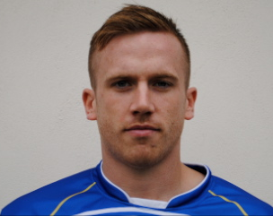

Last time I covered this feature, I was pointing out that Alex Rodrigues was just joining the top twenty appearance holders in club history. As soon as he had though, he departed to Egham!

I hope this doesn’t happen again, as we have three other players currently on this list.

Starting with Mark Jarman, who has 34 goals and is currently 47th in club history. You might think that 34 goals wouldn’t take too long to score, and indeed we have some players who have done it in just one season. However, when you had goal machines like the boys at the top knocking in the amounts they did, it’s easy to dismiss those lower down, yet 47th out of over 3,500 players is fairly significant in my book, and who knows how many more he may get for us in seasons to come.

Next up is our current Captain Jamie Hatfield. Like Jarman, has left the club only to return on a couple of occasions and those appearances keep mounting up. He is currently in joint 42nd position, along with Robbie Burns, who he should pass today, assuming he is fit.

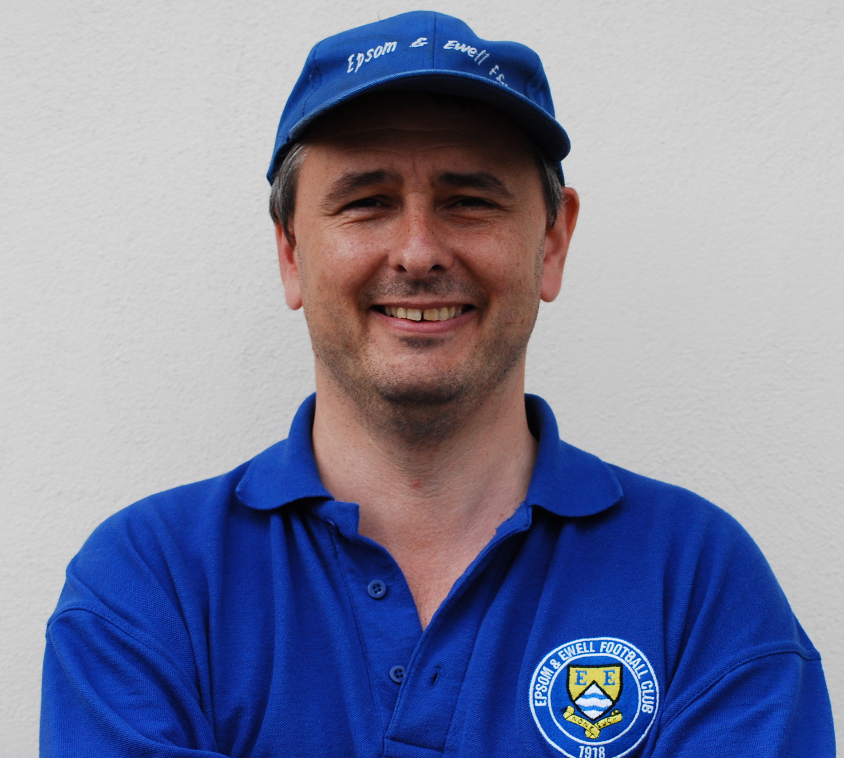


Finally, not far ahead of him is Ben Hayward. He has been with the club since joining us in early 2007 and is now the club’s longest serving continual player. I know some of you might say that he hasn’t played much this season, but it is work and not another club that has kept him away from the blue and white hoops. Has recently stepped back into the team and he is now up to 188 appearances, placing him in joint 35th position alongside Kyle Hough.

Congratulations all!

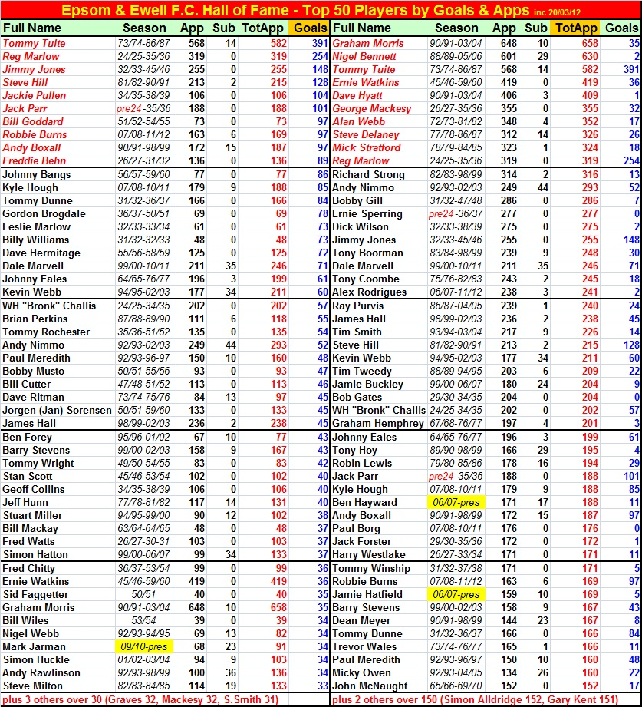
Steve Davies
Season Review

I started writing this review on the evening of our dreadful performance at home to bottom three club Chessington & Hook where we lost by the only goal of the game.

Now, the league table confirms that they are not a very good side so it was very frustrating to not only lose at home to them but to do so without seriously creating any scoring opportunities over the entire 90 minutes.

Because of this my season review was as depressing as an episode of Eastenders or a Catherine Cookson novel!

However, since then we picked up two valuable and unexpected points with a highly entertaining draw at Badshot Lea and a wonderful performance at champions Guildford City. Looking at the league table at that point, a win at home to Banstead would almost certainly keep us safe from any relegation worries. The win was achieved with some comfort but no-one foresaw the fantastic 2-0 win at high-flying Egham Town’s Runnymede Stadium which now leaves us comfortably mid table.

I have written before that supporting a football club takes one through many highs and many lows (though mostly lows unless you support a mega club like Manchester United or Barcelona) but this season, the last few games excepted, certainly has seemed to have been very lopsided on the “lows”.

In my case this poor season has been exaggerated as I have been absent from a lot of games this year and the ones that I have been present at have been mostly losses. Looking back I have only witnessed four Salts victories this entire season. These were the second game of the season at home to Colliers Wood, the home F.A. Cup tie on a sunny Sunday against Croydon, the F.A. Vase victory at Hailsham in September and the recent 3-1 league win at South Park. I would also like to throw onto the pile an awful 0-0 draw at Farnham Town.

My highlight of the season was undoubtedly James Cottee’s goal

at South Park which could have graced a Premiership game and be in the running for Match of the Day’s goal of the Month competition. Midway through the season I was becoming excited that my second favourite team, Leamington FC were having a fantastic season in the Southern League Premier, so I decided to pay the New Windmill Ground a few visits.

The plights of Leamington and the Salts have been similar as both clubs lost their ground. In Epsom’s case this resulted in 20 years of playing at the outposts of Merland Rise and Merstham while the loss of the Old Windmill Ground proved fatal to AP Leamington as they folded in 1988.

It was an incredible success story that they were resurrected in the year 2000 and in the seasons since then they have been promoted six times and it looked like they might actually make it seven times and win promotion to the Conference South but a 12 match winless run and a plethora of home draws have made even the play offs look very unlikely.

This poor run halted with a 2-1 win at Bedford town and as I write they are now unbeaten in 10 games but need an enormous helping hand from other results to make it into the play-offs.

I also took time out this season to check on Cambridge United but my visits have resulted in a 1-0 home reverse to Grimsby Town and a simply awful display of finishing by both sides in a tedious goalless draw against Hayes and Yeading at Woking’s Kingfield Stadium.

I am off to the Abbey Stadium on Tuesday (17th) to see the visit of York but the excitement of a play off place is now only a technical possibility for the Yellow and Black Army as they, like Leamington had a wretched run from December to February and their recent run of good form will be too little too late.

The future looks bright for next season for all three clubs and it would be nice if the Salts could can settle at Chipstead and have a decent home record as results overall at Moatside were very disappointing.

Most important would be a few wins in the FA Cup as the club’s finances are obviously in critical need of a boost.

Our Website
Our website http://www.pitchero.com/clubs/epsomandewellfc/ is still going strong, and if you are a regular visitor to it, you will see many updates.

In our current position with a lack of a decent local paper in the Epsom area, the website is the only way to communicate with Epsom supporters who are not at the games.

If you are a supporter, please pass the address on to anyone you know that has ever expressed an interest in the club, especially those who don’t visit any more. You never know, some of them might be inspired to come along too, and bring their friends etc.

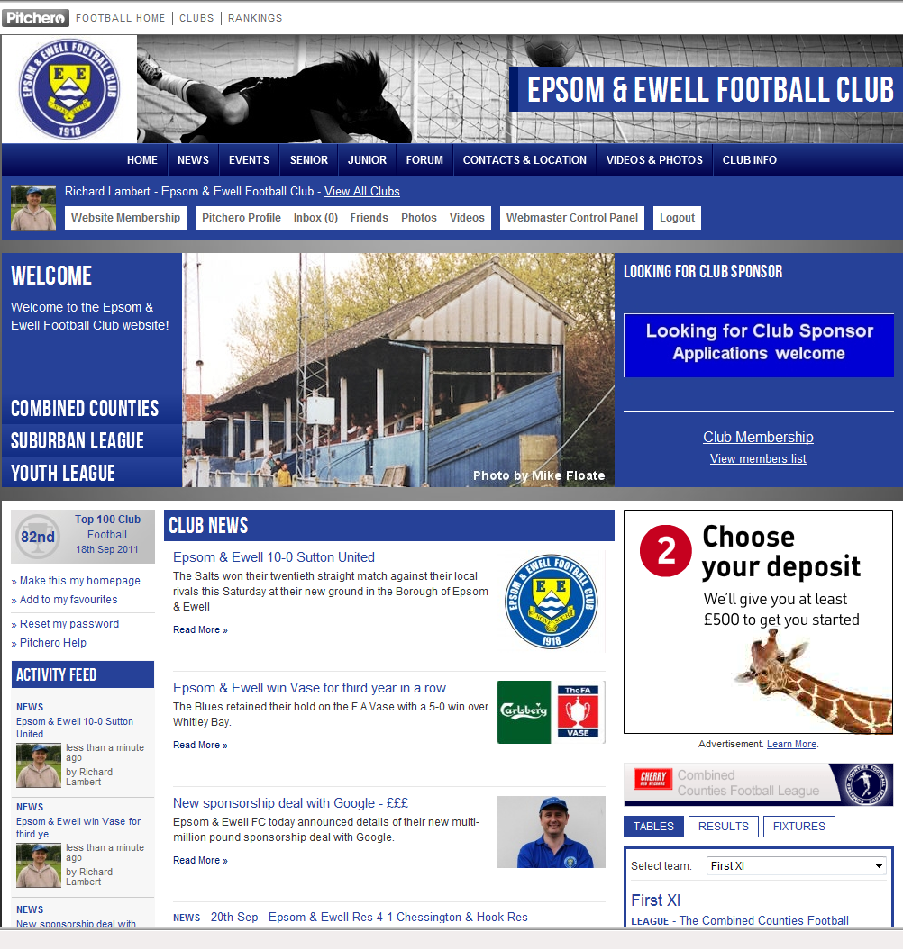

Epsom & Ewell on YouTube
Some of you will already be aware that clips of our games appear occasionally on YouTube at present. I thought I’d do a bit of research to see how often we have been filmed.

And this is what I found: Just copy the web address in and away you go. If I find any more I’ll let you know.

Happy viewing!

http://www.youtube.com/watch?v=Uew-Vx7-q7k
Epsom & E 1-4 Slough Town August 2003 (not the greatest quality) http://www.youtube.com/watch?v=bklC32K-gho
Epsom & E 3-0 Redhill (Surrey Senior Cup) 21/01/09 http://www.youtube.com/watch?v=AdGNeoQwgLM
Epsom & E 0-1 Molesey 17/10/09
http://www.youtube.com/watch?v=3pCYSmM_jb4
Horley Town 0-6 Epsom & E 24/10/09 http://www.youtube.com/watch?v=OMXs1YdxjHQ
Epsom & E 2-0 Horley Town 28/11/09 http://www.youtube.com/watch?v=hWOXIJDSji4
Dorking 0-5 Epsom & E 09/02/10
http://www.youtube.com/watch?v=4EP6Nn1I9TQ
Epsom & Ewell 1-1 Mole Valley SCR 21/08/10 http://www.youtube.com/watch?v=Qhy3-UyC54Q
Egham Town 3-1 Epsom & Ewell 04/09/10
http://www.youtube.com/watch?v=O8Gi6hsNi7M
Epsom & Ewell 1-1 Ash United 19/10/10
http://www.youtube.com/watch?v=mCZfDRWF6i8
Molesey 3-0 Epsom & Ewell 22/01/11
http://www.youtube.com/watch?v=SqdeS269aN0
Epsom & Ewell 3-2 Croydon 08/02/11
http://www.youtube.com/watch?v=7O9VPJsdco4
Epsom & Ewell 2-1 Horley Town 22/03/11
http://www.youtube.com/watch?v=Alq7MX7Fbj4
Horley Town 0-2 Epsom & Ewell 16/04/11
http://www.youtube.com/watch?v=zMbosAeSZCo
Epsom & Ewell 0-2 Horley Town 25/10/11
http://www.youtube.com/watch?v=gxT5H4lQDzM
Epsom & Ewell 0-1 Sutton United 06/12/11

In addition to that lot there is a DVD available showing our F.A.Cup defeat at Hythe Town, and there is also a DVD now available showing our last ever League match at West Street in 1993 against Aldershot Town. Just ask if you want a copy (£10).
Going further back we also have: http://www.youtube.com/watch?v=k65MEonAZzs
Inter Cardiff Ladies v Epsom & Ewell Ladies FA Cup 90's (Welsh version)

At a slight tangent to the above, I also found a link to footage of a punch up in an F.A. Youth Cup tie at Burgess Hill from a few years back!
http://www.youtube.com/watch?v=-ENIEreY6HQ

Player Sponsorship
 |     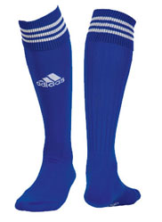  Please Sponsor one of our players for £40.00.  Just speak to any Committee Member.
Danny Amos
Nathan Ayling | Peter Coles
Ramzi Bedj Bedj | Steve Davies & Gary Ellis
Robbie Burns | Pizza2Go –  716 London Road, North Cheam 0208 6442211
Dan Coles | Joe Hagan P.G.A. Golf Pro – 07973 264151
James Cottee
Ali Dewar | ID & JD Services
Carl Downs | Mike and Janette Summers
Dave Francis | Paul Marshall & Dougie Burns
Paul Gough
Martin Grant
Jamie Hatfield | Pete Lumm
Ben Hayward | Geoff Dyke
Mark Jarman | Up and Out Lofts Ltd

Adrian Jones
Alex McGregor | John Bonner
Alex McKay
Antony “Freddie” Myers | Tony Jeffcoate
Anthony Panayi | The Boys behind the goal
Sam Robinson | Geoff and Arnold Pye
Alex Rodrigues | Pete Beddoe
Joshua Smith
Matt Smith | The Jarman Family
Jamie Summers | Dave Ellins
Nick Taylor-Greaves
Paul West | Someone Has To Ltd!
Ross White
Lyndon Buckwell | Darryl Hatfield
Tony Coombe
Glynn Mandeville | Mark Jarman
Ken Jones
Tony Knight | Paul West

This Season’s Match Sponsors
Fixture | Date | Match Sponsor | Ball Sponsor
Colliers Wood United | 09/08/11 | Epsom & Ewell F.C.  Management Committee
Windsor | 13/08/11 | Richard Lambert
Croydon | 21/08/11 | Joe Hagan P.G.A. Golf Pro – 07973 264151
Guildford City | 23/08/11 | Steve Dyke
Mole Valley SCR | 27/08/11 | Tony Jeffcoate
Chipstead | 04/09/11 | Pete Beddoe | Paul Merritt
Hanworth Villa | 08/10/11 | Joe Hagan P.G.A. Golf Pro – 07973 264151
Horley Town | 25/10/11 |  | Pete Beddoe
Badshot Lea | 29/10/11 | Geoff Dyke
South Park | 12/11/11 | Gemma and Kirsty Herbert
Croydon | 19/11/11 | Mid-Surrey Mencap | Dave and Nicola Beddoe
Sutton United | 06/12/11 | In memory of Chris Henry
Raynes Park Vale | 17/01/12 | Amit Badani
Dorking | 28/01/12 |  | Maggie Beddoe
Ash United | 17/03/12 |  | Pete Beddoe
Farnham Town | 20/03/12 |  | Dave & Nicola Beddoe
Chessington & Hook | 31/03/12 | Epsom Coaches | Nathan Lambert
Banstead Athletic | 09/04/12 | Tony Foster | Epsom Coaches
Camberley Town | 21/04/12

Alan Carter’s Answers – Quiz 23
1. Two from Owen Hargreaves (Bayern Munich), Kevin Keegan (SV Hamburg), Tony Woodcock (FC Koln) & Dave Watson (Werder Bremen).
2. Luxembourg (18 consecutive failed qualification attempts from 1934 to 2010).
3. Crystal Palace (relegated 1992-93, 1994-95, 1997-98 & 2004-05).
4. Gary Lineker; Leicester City (24 goals, 1984-85), Everton (30 goals 1985-86) & Tottenham Hotspur (24 goals 1989-90).
5: 12 (92-93, 93-94, 95-96, 96-97, 98-99, 99-00, 00-01, 02-03, 06-07, 07-08, 08-09, 10-11) 6: Trevor Steven in England (Everton, 1985 & 1987), Scotland (Rangers, 1989 & 1997) and France (Marseille, 1992).
7: Five: Crewe Alexandra, Exeter City, Halifax Town, Oxford United and Wrexham.
8: The 2006 World Cup Finals in Germany.
9: Bolton Wanderers are currently playing their 73rd season in the Top Flight and have never won the League Title.

Epsom & Ewell Football Club - History
We were founded in March 1918 as Epsom Juniors Cricket Club and played throughout the summer. In the autumn, Epsom Juniors F.C. came into being and they played a handful of games from what is now known as Alexandra Recreation Ground. Competitive football followed as the club entered the Surrey Junior League in 1919, and then became founder members of the Sutton & District League in 1920.

A change of name in July 1922 to Epsom Town F.C. heralded the start of a very successful era. By now resident at the Horton Hospital Sports Ground, we were unfortunate to lose 2-1 after extra time at Dorking F.C.’s Pixham Lane ground to Caterham Mental Hospital in a replay of the Surrey Junior Cup Final. However, we won three other trophies that season, the Leatherhead Hospital Shield, the Sutton Hospital Cup, and the Epsom Hospital Cup. In addition, the Club also won the Sutton & District League, and under the forward thinking of their Chairman Hugh Bradley, took the step into Intermediate Football, where we won the Southern Suburban League without losing a match. Senior football was granted the next season, as we were unanimously accepted into the Surrey Senior League for 1924/25, finishing third.

In September 1925, the club relocated to the old Ewell F.C. ground at West Street, which was purchased through the generosity of the Club’s future President Robert Bradshaw. In 1925/26 the Championship of the Surrey Senior League was attained, and the following season, we did the “double”, defeating Egham 1-0 at Egham in the League Charity Cup. Election to the London League was next, and the title was claimed in the club’s first season there in 1927/28. Unfortunately, we were unable to repeat this, although we would finish runners-up in 31/32, 32/33, 34/35, 36/37 and 37/38. Cup Honours were limited, although Redhill defeated us 3-2 in front of 4,600 at Guildford in their first Surrey Senior Cup Final, having seen off Wimbledon 4-1 in the semi-final! Also, the club won the Surrey Charity (Senior) Shield in 1933 with an impressive 5-0 win over Woking at Kingfield. However, the proudest moment of the club’s pre-war history was an appearance in the First Round Proper of the F.A.Cup in 1933/34. Woking (after a replay), Nunhead, Tooting & Mitcham, Beddington Corner, and Leytonstone were defeated, and a crowd of 9,485 at the Lea Bridge Speedway Stadium witnessed a 4-2 loss against the hosts Clapton Orient. At the end of that season the club changed its name to Epsom F.C. while in 1936 the closure of the Reserve team enabled the newly formed Ewell and Stoneleigh to spend two years there ground sharing while they were in the Surrey Senior League. Local works team Venners Sports took their place as tenants in the final completed pre-war season.

In 1939 a newly formed team, Epsom Town (no connection to the earlier team) shared the ground with Epsom F.C. However, this arrangement was suspended when war was declared, and the parent club folded for the duration. In the meantime, Club Chairman Charles Pettett threw in his lot with Epsom Town in an attempt to keep morale up in the town by keeping the football flag flying. It was successful, as the club competed throughout the war years, winning the Surrey Combination in 1939/40, and reaching the Surrey Senior Cup Final in 1944, losing 3-1 to Tooting & Mitcham, at Sandy Lane. After the war, Epsom F.C. started up again, continuing in the London League and reclaimed their ground, leaving Epsom Town homeless. Temporary homes were found at Kings College, Lavender Avenue, Mitcham, and then at the Old Halleyburians Rugby Ground in Ruxley Lane, as they competed for a season in the newly created Corinthian League, but disbanded in 1946.

In 1949 Epsom F.C. entered the Corinthian League themselves, but despite a 3-2 win over Champions Walton & Hersham in our first home match, we would not win an away match for nearly three years. We did reach the Corinthian Memorial Shield Final in 1952, going down 2-1 to Champions Hounslow at Eastbourne after leading at half-time. Things improved with the signing of the ex-Amateur International Pat Lynch from Hendon; the club achieved our highest ever placing of third in 1952/53, and in 1954 reached the Surrey Senior Cup Final for the third time in our history, losing unluckily 2-0 to Corinthian Casuals in front of 6,159 at Selhurst Park, while in 1955 we won the Surrey Senior Shield with a 1-0 win over Carshalton Athletic at West Street.

There was a massive new player influx in 1955 after the club appointed their first ever Manager in Kingstonian legend Doug Whitehead. The Corinthian League double was almost achieved in 1956/57, but two losses in the final week, along with defeat in the Cup Final 2-0 to Maidenhead United at Dorking, ensured that the club got neither, finishing fourth. However in 1960, we finally held the Shield with a 2-0 revenge win over Maidenhead United at Vale Farm, home of Wembley F.C. This was the last season at the club for Ernie Watkins, who had played for the club since the end of the war. However, he would go on to play for eight more years at Banstead Athletic before finally retiring in 1968 aged 47!

In 1960 the club changed its name once again to Epsom & Ewell F.C. This was not because of any merger with Ewell & Stoneleigh as is often quoted, but was an attempt to increase support across the whole of the Borough. In 1963 the Corinthian League merged with the Athenian and Delphian Leagues, and the club were placed in Division One of the new structure, but the sixties were full of poor results and relegation was the result in 1965. Despite a string of managers, most notably ex-Leyton Orient winger Jimmy Smith, and Tony Williams, now famous for his creation of the F.A. Yearbooks, the club’s fortunes did not improve significantly, and further relegations were avoided in the early seventies by the benefit of re-election. However in 1973, despite “improving” to finish second from bottom, the Athenian League ran out of patience and cut them loose. This was unfortunate timing as we had just cleared all of our debts, and in addition to a virtually new Committee, former Fulham player Pat O’Connell took over the reins.

The Surrey Senior League took us in at the last minute, and the new squad, including young striker Tommy Tuite, won the League Cup, and the following season the club achieved their second Surrey Senior League “double”. However, season 1974/75 would always be remembered for reaching the Final of the inaugural F.A. Vase, where 9,500 saw the Blues edged out 2-1 by Hoddesdon Town at Wembley Stadium. The Athenian League welcomed us back, and despite losing Trevor Lee and Phil Walker to Millwall in November 1975 promotion was achieved, and the next season we reached the Athenian League Cup Final, losing 1-0 at Chalfont St Peter.

In season 1977/78 many clubs were invited to join the expanding Isthmian League, and Epsom & Ewell were placed in the new Division Two. Our first match under floodlights followed against Met Police, and the Championship was clinched the following April. In 1979/80 we won the Southern Combination Cup 7-2 at Hampton, where the hosts were blitzed by five goals from Tuite. The following season a new clubhouse opened at West Street, and we finally won the Surrey Senior Cup, defeating Woking 2-1 at Tooting & Mitcham. The club just missed out on promotion to the Premier Division that season, but in 1983/84 we went up as runners-up, although this time we were defeated in the Surrey Senior Cup Final, 4-0 by Sutton United at Imber Court.

With Adrian Hill as Manager since 1982, the club survived comfortably in its first season at the new level, but Hill’s departure to Croydon in 1985 started a decline. Much of the squad also left with Hill, and new Manager Alan Webb had too much to do. The club was relegated, and following Webb’s departure in 1986, Player / Manager Ricky Kidd nearly but not quite saved the club from its second straight relegation. Adrian Hill replaced Kidd for a second spell at the helm in 1990, but we were placed in the new Division Three in 1991 in league reorganisation following a finish one position below the required half way mark.

In 1993 we left West Street and moved in as tenants of Banstead Athletic. The decade was largely one of frustration, although the Final of the Associate Members Trophy was reached, where Bedford Town edged us out 2-0 at Hendon’s old Claremont Road ground.

In 2002 Adrian Hill took the club back up to Division 1 South, where they topped the table for a month, eventually finishing 9th, but Hill’s retirement at the end of the season led to relegation a year later. Two seasons in Division 2 followed before it was disbanded in the latest F.A. reorganisation, and we now compete in the Combined Counties League Premier Division under the guidance of manager Lyndon Buckwell, a former player at the club. Lyndon has been here since October 2006, and his first full season (2007/08) resulted in our first top ten finish since 2003. In 2008/09 the team exceeded this achievement and finished in fourth place after heading the table for the first few months of the season. In 2009/10 the club recovered from a slow start to finish fifth and also reached the last 32 of the F.A.Vase for the first time in 21 years, bowing out 3-2 in Northamptonshire to Long Buckby. In April of 2010 we terminated our seventeen-year ground sharing agreement with Banstead Athletic and spent two unspectacular seasons at Merstham F.C. today before relocating to Chipstead F.C.

Meanwhile, the search continues for a new ground back in the Borough………
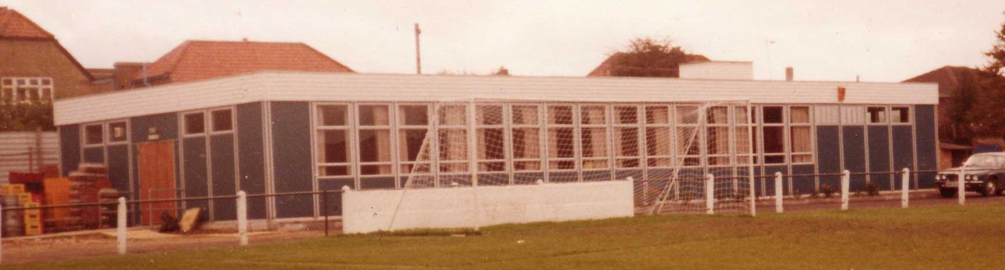

Thank You
For five years now, I have been compiling the match programme, the last four as Editor.

We have had good seasons, frustrating seasons when we knew we could do better, and poor seasons. This one has been poor.

Don’t get me wrong here, I am not having a go at anyone in particular. Various circumstances have conspired against us, although Lyndon’s comments from the previous programme where he says his team haven’t been good enough doesn’t tell the full story. This club hasn’t been good enough this season, both on and off the field this season, myself included, and only the very gullible at this club could genuinely look at themselves in the mirror this year and say that they couldn’t have done any better. I do not need to go into detail here.

It is quite clear that we face some very dark days ahead at this club. An upcoming meeting between the Club Committee and our Holding Company is pivotal in determining exactly what future we have, and for how much longer we can survive without getting a new ground back in the Borough.

As Club Historian, I can report that we have had dark days before and we have come through them to survive and flourish, so it is possible to get out of this hole. However, it needs a lot of people to help build a ladder out this time.

In short, the club needs both financial and voluntary help, but must be better organised too. On behalf of the club I apologise to the supporters and players here regarding the six-point deduction that made our end of season a little tenser than it needed to be. It was totally unprofessional for a club of our standing and must never be allowed to happen again.

We also hope that you will all follow us to Chipstead F.C. next season. It is no secret that attendances have dropped from what they were at Merland Rise, although neither I, nor the club make any apology for the end of our tenure at Banstead Athletic as it represented a significant saving after years of the ground sharing agreement being neglected. The move was long overdue and should have happened earlier. In my opinion this was also the case with our Reserve and Youth teams, and whilst it is disappointing to put them into cold storage, our survival must come first.

What is also clear is that whilst facilities here at Merstham have been significantly better than those we had been using for many years, the club maybe didn’t fully think through the effect that the travelling distance would provide on its supporters. As we move forward, it is very clear that more thought and consultation needs to be taken before important decisions are made by your Club Committee. The World is changing and we must keep up.

That said; if it weren’t for those who sacrifice their time by joining the Committee, we would have no club, and it is with them that I start my round up of thank you’s.

Our hasty appointment of a General Secretary has proven to be a complete failure this season, so Chairman Tony Jeffcoate stepped in and took the role on. Assisted by Vice-Chairman Pete Beddoe, they were regulars in particular at our Youth and Reserve matches this season as other Committee members were rarely able to help on those extra days.

We lost two other members of the Committee during the season in Dougie Burns and Ian Twyford, although we were able to add Paul Marshall to our ranks; another long-serving supporter who has been very reliable in carrying out various match day duties from getting the nets and posts ready to substituting on the gate when Pete Beddoe was away.

Of the others, Tony Foster, Steve Dyke and myself have all been putting the hours in behind the scenes. Of course, Tony’s job of Treasurer has little externally to show for it except at the AGM, while myself and Steve have not been as publicly prominent as last season, when we were involved with the Supporters Fund-Raising Exercise. I can assure you though; we have all still been busy!

The final person on the Committee is Lyndon Buckwell, who has had a lot of issues to deal with this season as Manager. We started with a number of new players, and a significant injury crisis derailed our season before it had got off the ground. Narrow defeat at home to Chipstead in the F.A.Cup was followed by a Vase defeat at Ringmer before he had the chance to put a settled side together. The six-point deduction didn’t help, although I think it is fair to say that even with six points back, both the club and Lyndon were hoping for a higher finish anyway, but these things happen. I know that he and his Management team of Glynn Mandeville, Tony Knight, Tony Coombe and Ken Jones have worked hard this season, which is all you can ask for.

I’d also like to thank Les Smithers, who produced excellent results at his time at the helm of the Reserve Team, and Trevor Jones whose Youth Team were so close to real success on four different fronts this year.

I’d like to thank my Editorial Team (detailed on earlier pages) for their help over the season. We have a good programme that takes an age to produce and it is important while we are away from the Borough, that we provide as much information as we can to people, not only in the programme, but on the web site, the social networking forums and Twitter, where Alan Carter and Janice Pond have put in a lot of time.

In addition, I think the different styles and variety of our contributors has given some real choice for readers. If you don’t like one part of the programme, you will turn the page and hopefully find something else that you will like. I’d like to thank our match and player sponsors and in particular, Dougie Burns for getting many of them on board and showing exactly how well fund-raising can be done with the correct drive and motivation.

I’d also like to thank Tom Siefers’ dad for saying that our programme is “always the same old stuff”. I’m not quite sure what he expected to find in it; to paraphrase John Cleese as Basil Fawlty, maybe “the Hanging Gardens of Babylon, or a herd of wildebeest sweeping across the pages”. However, his

comments did remind me that we can never rest on our laurels, and maybe there are ways that we can further improve the programme, while also bearing in mind production costs. I will continue to try next season.

We are obviously indebted to Merstham F.C. for allowing us to share their excellent facilities for the last two seasons, and in particular Richard Baxter, Martin Burr and Ted Hickman who have provided help when required. I look forward to the day we can return here as equals for a Step Four (or higher) League match. In addition, thank you to Sally at the Tea Bar and to Helena who dealt with a lot of the Match Day hospitality in the Boardroom. Always, service with a smile from both.

I’d also like to thank the players, starting, maybe oddly, with one who is no longer here. Alex Rodrigues left us in the Spring after nearly five years here. His ever-present record that had been well-documented at the club, ended this season at 188, which is a fantastic run only beaten once before in club history.

Whilst I cannot name all of our other players here, I’d like to thank a few of them. Firstly, Jamie Hatfield who proved to me that some players do read the programme! To Anthony Panayi for tweeting me my first mention (speak to a youngster for a better description, as I’m still not sure how it all works!), to Carl Downs for often taking the time to stop and have a chat with the supporters, and finally to James Cottee for being particularly exciting to watch since joining us in November. He is one of my favourite players we have had here since Lyndon took over, and I hope he stays with us for at least one more season.

I must also thank Radio Marsden who have been covering our progress on Saturdays this season and their advert is shown elsewhere in the programme.

And finally to our supporters, especially those who have been regulars here. Over the course of the season I have been made aware through the website of a supporter who lives in Australia, while another is in Austria and even possessed some replica kit. They are everywhere! It seems that the move has tested a few loyalties, but they are still there in cyberspace even if not all in person.

Despite your help and support, we need more from you all if this club is to progress. Not just financial, although Match and Player Sponsorship is very welcome thank you, but if you think you can spare more time, please contact us. You don’t necessarily have to be a regular supporter to fill some holes that I have in mind to bring this club into the 21st Century, in particular with reference to Public Relations, merchandising or fund-raising areas, all of which have been neglected recently, so don’t be put off or think you can’t help, just because you can’t get to many games, as it is not pivotal for any of these roles.

Some of you in the past may have been put off by the substantial amount of secrecy at the club relating mostly, but not exclusively to our attempts to get a new ground. I know I was for many years, but by the start of the new season it is hoped there will be a much better dialogue between the relevant parties and whilst obviously some information is sensitive, you will be kept advised of as much as possible, as soon as possible. I promise you that.

See you all at Chipstead next season. Enjoy the break!!

Camberley Town – History
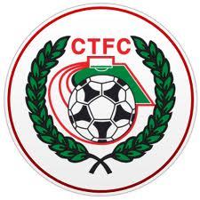
Not a lot is known about the formation of what is now Camberley Town FC. A copy of a Surrey Senior League Handbook of 1939 refers to Camberley & Yorktown being affiliated to the Surrey F.A. in January 1896, so it is possible that the club formed in 1895.

Camberley & Yorktown won their first trophy within two seasons of formation, when in 1897/98 the Club beat Norwood & Selhurst 2-1 in the final of the Surrey Junior Cup. As far as it is known, Camberley & Yorktown initially competed in the Ascot & District League, winning the league title in 1904/05. The Club went on to appear in three Surrey Junior Cup Finals, the first in 1907/08 when Camberley & Yorktown took on Kingston at Woking and were beaten 2-0. In 1908/09 Camberley reached their second final where they lost to Selhurst Park 1-0. but in 1909/10 saw victory at last over Sutton United 2-1.

1913/14 saw Camberley & Yorktown make their first appearances in the F.A. & F.A. Amateur Cups. On September 13th Camberley & Yorktown played host to Sutton United and won 5-3 in their first F.A. Cup match. The first F.A. Amateur Cup game did not go well when soundly beaten 7-0 by the Royal Army Medical Corps. After the Great War, Camberley & Yorktown concentrated their efforts on the Aldershot Senior League. They started 1919/20 well scoring 26 goals in three pre-season friendlies, which included a 15-0 record victory over Royal Engineers, a record that still stands.

In 1922 the Club became founder members of the Surrey Senior League. They celebrated this by moving into the present ground at Krooner Park. The 1930's saw unequalled success as the side won the Surrey Senior League Championship three times in a row. Between 1930/31 and 1932/33 Camberley & Yorktown narrowly missed out on another piece of silverware when they lost 2-1 to Beddington Corner in the Surrey Senior League Charity Cup Final.

The Club reached their 40th anniversary in 1935/36 and celebrated it by reaching the Surrey Senior Cup Final for the first time where they were beaten 3-1 by Wimbledon. Camberley & Yorktown followed up the following season with another appearance in the Surrey Senior League Charity Cup Final losing 5-0 to Walton on Thames. In 1937/38 they went one further, winning the Surrey Senior League Charity Cup 3-2 over Hersham.

Upon resumption Camberley & Yorktown dropped the Yorktown part of the name and became known as Camberley FC. Krooner Park was not ready for use again by the time the League resumed so the Club started the season at the London Road Recreation Ground. Success was hard to obtain with only a victory in the Surrey Senior Charity Cup in 1952 against Chertsey and a further appearance in the same final three seasons later to show for their efforts in the fifties and sixties.

In 1967 discussions took place between the two senior teams in the town, Camberley Wanderers and Camberley F.C. The two clubs decided to merge and on 2nd June 1967 became Camberley Town F.C. and joined the Isthmian League in 1977. Promotion was achieved in 1979 along with victory in the Final of the Surrey Senior Cup where Leatherhead were beaten 4-1 after extra time.

In 1986 the Club enjoyed their best run in the F.A. Vase reaching the Quarter-Finals before losing to eventual winners Halesowen Town. They won the Aldershot Senior Cup in 1996/97 and 1997/98. 1997/98 also saw Camberley reach the 4th Qualifying Round of the F.A. Cup equalling their best performance since the thirties and they missed out on promotion to Ryman Division 2 on the final day of the season after a great run. In 1998/99 Camberley went one better in the F.A. Cup, reaching the 1st Round Proper for the first time where Brentford knocked them out.

Supporters Player of the Match 2011/12
09/08/11 | H | Colliers Wood Utd | CCL | 3-1 | Chris Woodward
13/08/11 | H | Windsor | CCL | 2-2 | Dave Francis
16/08/11 | A | Farnham Town | CCL | 0-0 | Alex Rodrigues
21/08/11 | H | Croydon | FAC | 3-1 | Matt Smith
23/08/11 | H | Guildford City | CCL | 2-3 | Alex McGregor
27/08/11 | H | Mole Valley SCR | CCL | 3-1 | Antony Myers
29/08/11 | A | Raynes Park Vale | CCL | 2-3 | Jamie Summers
04/09/11 | H | Chipstead | FAC | 1-2 | Jamie Summers
10/09/11 | A | Hailsham Town | FAV | 3-1 | Robbie Burns
17/09/11 | A | Sandhurst Town | CCL | 1-3 | Robbie Burns
24/09/11 | A | Ringmer | FAV | 0-2 | Dan Coles
September |  | Monthly Award |  |  | Dan Coles
01/10/11 | H | Molesey | CCL | 2-0 | Matt Smith
04/10/11 | A | Knaphill | CCLC | 3-2 | Dave Francis
08/10/11 | H | Hanworth Villa | CCL | 2-2 | Jamie Hatfield
11/10/11 | A | Dorking | CCL | 1-1 | Mark Jarman
15/10/11 | A | Ash United | CCL | 4-1 | Carl Downs
22/10/11 | A | Wembley | CCL | 1-4 | Mark Jarman
25/10/11 | H | Horley Town | CCL | 0-2 | Nathan Ayling
29/10/11 | H | Badshot Lea | CCL | 0-2 | Ali Dewar
October |  | Monthly Award |  |  | Jamie Hatfield
05/11/11 | A | Camberley Town | CCL | 0-4 | Jamie Summers
12/11/11 | H | South Park | CCL | 3-1 | Sam Robinson
19/11/11 | H | Croydon | CCL | 2-1 | Mark Jarman
26/11/11 | A | Windsor | CCL | 0-1 | Dan Coles
November |  | Monthly Award |  |  | Sam Robinson
03/12/11 | H | Egham Town | CCL | 1-4 | Dan Coles
06/12/11 | H | Sutton United | SSC | 0-1 | Adrian Jones
10/12/11 | A | Chessington & Hook Utd | CCL | 5-5 | Sam Robinson
17/12/11 | H | Cove | CCL | 2-3 | James Cottee
27/12/11 | A | Banstead Athletic | CCL | 1-0 | Adrian Jones
December |  | Monthly Award |  |  | Carl Downs
07/01/12 | A | Worcester Park | CCLC | 1-4 | Antony Myers
14/01/12 | H | Wembley | CCL | 1-0 | James Cottee
17/01/12 | H | Raynes Park Vale | CCL | 1-2 | James Cottee
21/01/12 | A | Croydon | CCL | 2-2 | Mark Jarman
28/01/12 | H | Dorking | CCL | 5-0 | James Cottee
January |  | Monthly Award |  |  | James Cottee
18/02/12 | A | Horley Town | CCL | 1-3 | Nathan Ayling
25/02/12 | H | Sandhurst Town | CCL | 2-3 | James Cottee
28/02/12 | A | South Park | CCL | 3-1 | James Cottee
February |  | Monthly Award |  |  | James Cottee
03/03/12 | A | Hanworth Villa | CCL | 3-0 | Carl Downs
06/03/12 | H | Molesey | CCL | 0-6 | held over to next game
10/03/12 | A | Mole Valley SCR | CCL | 4-2 | Nathan Ayling
17/03/12 | H | Ash United | CCL | 0-2 | Mark Jarman
20/03/12 | H | Farnham Town | CCL | 1-4 | Ali Dewar
31/03/12 | H | Chessington & Hook United | CCL | 0-1 | held over to next game
March |  | Monthly Award |  |  | Jamie Hatfield
03/04/12 | A | Badshot Lea | CCL | 2-2 | Carl Downs
07/04/12 | A | Guildford City | CCL | 1-1 | Nick Taylor-Greaves
09/04/12 | H | Banstead Athletic | CCL | 2-0 | James Cottee
14/04/12 | A | Egham Town | CCL | 2-0 | Ramzi Bedj Bedj
21/04/12 | H | Camberley Town | CCL
27/04/12 | A | Colliers Wood United | CCL
April |  | Monthly Award |  |  | ??

Photos of the Season

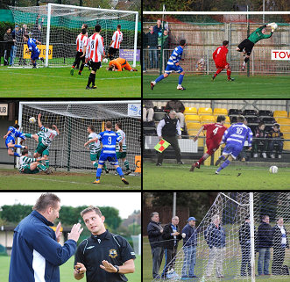
Over the course of the season Gemma has caught some great action and some other, different pictures! I have spared Glynn Mandeville from his Saturday Night Fever pose, but here are six of my favourites!

- Dave Francis has just scored the equaliser against Hanworth Villa, but I think the keeper is a bit embarrassed by his fumble moments earlier.
- Dan Coles making one of many great saves at Windsor in November.
- Jamie Summers leaps like a salmon to head our second goal in the 5-0 home win over Dorking in January.
- I recognise that Assistant Referee at home to Wembley in January!
- The Badshot Lea Manager is in trouble. What I liked about this picture was that they both really needed a curly black wig and a scouse accent. Calm down!
- Approximately 230 years of service stood behind the goal at Worcester Park and all of us wondering whether we might have wasted our lives!

Combined Counties League – Premier Division
Saturday, 21st April 2012 - Kick-off 3.00 p.m.
Epsom and Ewell  (Royal Blue & White hoops) | V |  | Camberley Town  (Red and White)
 | NUMBERS
Nick Taylor-Greaves |  |  | Stuart Norman
Matt Smith |  |  | Andrew Grace
(capt) Jamie Hatfield |  |  | Paul Andrews
Jamie Summers |  |  | Dale Webb
Anthony Panayi |  |  | Bence Kator
Carl Downs |  |  | Martin Girling
Ali Dewar |  |  | Jeff Cavey
Nathan Ayling |  |  | Louis Hibbert
Mark Jarman |  |  | Joe Paris
James Cottee |  |  | Joe Wilson
Antony Myers |  |  | Matt Barclay
Ramzi Bedj Bedj |  |  | Brett Wickens
Paul Gough |  |  | Alex Lumley
Ross White |  |  | Rob Carrick
Adam Cheadle |  |  | Jay Warden
Jordan Cheadle |  |  | Stacey Thripp
Aaron Williams
Daniel Amos
James Moon
Ryan Augustine
Lyndon Buckwell | MANAGER |  | Darren Barnard
Glynn Mandeville /  Tony Coombe | ASSISTANTS
Tony Knight | COACH |  | Neil Woodyer
Ken Jones | PHYSIO |  | Geoff Dadswell
REFEREE: J.Ryan (Worcester Park)
ASSISTANTS: S.Earl (Mitcham), S.Richardson (Sandhurst)
Epsom & Ewell F.C.
thank you all for your support this season and look forward to seeing
you at Chipstead F.C. next year

